The effects of field inoculation of arbuscular mycorrhizal fungi through rye donor plants on grapevine performance and soil properties
Amaia Nogales¹*, Emilien Rottier^{1,2}, Catarina Campos³, Gonçalo Victorino¹, Joaquim Miguel Costa¹, João Lucas Coito¹, H. Sofia Pereira¹, Wanda Viegas¹, Carlos Lopes¹
¹Linking Landscape, Environment, Agriculture and Food (LEAF), Instituto Superior de Agronomia (ISA), Universidade de Lisboa, Tapada da Ajuda 1349-017 Lisbon, Portugal.
² Université Picardie Jules-Verne, Amiens, France.
³ Instituto Mediterrâneo para a Agricultura, Ambiente e Desenvolvimento (MED). Instituto de Investigação e Formação Avançada, Universidade de Évora. Pólo da Mitra, Ap. 94, 7006-554 Évora, Portugal.
* Corresponding author : anogales@isa.ulisboa.pt (Amaia Nogales)
Abstract
Grapevines are highly dependent on arbuscular mycorrhizal fungi (AMF) for normal growth and development. However, vineyard soils may have low AMF abundance and diversity due to conventional soil management practices that are detrimental for these fungi. In this context, the establishment of AMF-inoculated cover crops can be a highly convenient strategy to reestablish soil mycorrhizal potential, as it combines the advantages of a vigorous inoculum source coming from mycorrhizal donor plants with the overall benefits of green covers for grape quality, microbial diversity and soil health. In this work, the potential benefits of Funneliformis mosseae-inoculated under-vine cover crops on grapevine growth, physiology and production were compared to those derived from 1) the establishment of non-inoculated under-vine cover crops, and 2) conventional herbicide-based weed control in the under-vine space. In addition, grapevine root AMF community composition was analyzed to assess if the introduction of a non-native AMF species induced changes on resident mycorrhizal community assemblies and to unveil potential variations in AMF diversity associated to herbicide replacement by green covers. Results indicated that under-vine cover crops, inoculated or not, led to a general vigor decrease in grapevines, probably due to competition between the two species. However, after a heat wave that occurred at harvest time in the second year of the experiment, grapevines growing in plots with inoculated cover crops had the highest photochemical reflectance indices and net photosynthesis rates, and partially compensated production losses due to berry sunburn. Root mycorrhizal community analysis by the end of the experiment revealed that the inoculated F. mosseae isolate colonized grapevine roots from inoculated plots, while it was absent in the other ones. Moreover, inoculation of this AMF did not lead to a replacement of native root AMF communities, but allowed further colonization by other resident Glomeraceae and non-Glomeraceae AMF taxa. Overall, the work herein demonstrates that the introduction of F. mosseae through donor plants is a suitable field inoculation method for grapevines and can help them to better withstand heat waves.
Key words: Vitis vinifera L.; Secale cereale L; Funneliformis mosseae, mycorrhizal communities; cover crops; sustainable soil management

1 Introduction
Arbuscular mycorrhizal fungi (AMF) are a natural and integral component of healthy soil ecosystems. They form mutualistic symbiosis with most crop species, including grapevines, that are in turn dependent on them for their normal growth and development (Trouvelot et al., 2015)⁠. Mycorrhizal symbiosis offers multiple ecological services to agricultural systems, i.e. by promoting plant/crop growth, nutrient uptake and stress tolerance, and thus, reducing fertilizer and phytochemical requirements; by enhancing soil aggregation, water retention, nutrient cycling and microbial diversity, thereby improving soil quality; and by phyto-stabilizing certain contaminants (Gianinazzi et al., 2010)⁠⁠.
However, current agricultural practices (e.g. high nutrient and biocide inputs, soil tillage, monoculture, cultivation of non-mycotrophic crops) are detrimental to the abundance and diversity of AMF communities and their associated beneficial microorganisms (Jansa et al., 2006)⁠. This results in agrosystems that are deprived of the full range of benefits that AMF can provide to the crops (Gosling et al., 2006). In order to offset this negative impact and to reestablish mycorrhizal potential in agricultural soils, two possible strategies can be used: 1) adoption of field practices that enhance indigenous populations of AMF (Brígido et al., 2017; Brito et al., 2008; Lehman et al., 2012), and/or 2) plant/soil inoculation with selected AMF species (Belew et al., 2010; Camprubí et al., 2008; Juntahum et al., 2020; Nogales et al., 2009, 2008).
The establishment of cover crops is a sustainable soil management practice that promotes the proliferation of natural mycorrhizal communities (Brígido et al., 2017; Brito et al., 2013; Kabir and Koide, 2000; Soti et al., 2016). Moreover, cover crops are an alternative to herbicides and to soil tillage for weed control, and provide a variety of benefits to the soil, by preventing erosion, improving water holding capacity and infiltration rates (Basche and DeLonge, 2019), and by increasing soil organic matter as well as overall biodiversity (Costello and Daane, 1998; Kim et al., 2020; Steenwerth and Belina, 2008; Vukicevich et al., 2016). Furthermore, mycorrhizal hyphae originating from cover crops can colonize cash crop roots and form mycorrhizal links between the two species, favoring the transfer of nutrients (Cheng and Baumgartner, 2005).
Nevertheless, native AMF are usually subjected to intense selection pressures in monocultures, especially in conventionally managed soils (Oehl and Koch, 2018). The resulting AMF communities are typically dominated by few taxa, that are presumably well adapted to those agricultural conditions but that are less mutualistic i.e. provide little or no benefit to the plant (Verbruggen and Toby Kiers, 2010). In such agrosystems, inoculation with selected AMF may be a good strategy to improve crop performance as well as to increase productivity.
Several AMF species have been domesticated and many commercial mycorrhizal-based inoculants are available worldwide (Gianinazzi, 2014). However, whereas direct field inoculation in annual crops is feasible when appropriate machinery is available, direct inoculation of individual plants in woody perennial crops such as grapevines, is overly laborious, expensive, and technically challenging due to the deep root systems of this species. Hence, the development of new cost-effective methods for AMF inoculation in vineyards are needed. In this context, the establishment of mycorrhizal cover crops beneath grapevines as neighboring donor plants (under-vine cover crops) represents a simple and efficient method to increase mycorrhizal potential in the soil as well as to inoculate grapevines with well-selected and effective AMF. Strategically, this methodology combines the advantages of a vigorous inoculum source [the extraradical mycelium coming from a donor plant is much more infective than spores and mycorrhizal root fragments (Brito et al., 2009)] with the significant benefits of cover crops on AMF diversity, soil health, and grape quality (Lopes et al., 2008; Schipanski et al., 2014; Soti et al., 2016).
The objective of this work was therefore to test the hypothesis that the establishment of mycorrhizal cover crops as AMF donor plants is a suitable strategy for inoculating grapevines under field conditions, and that it provides an overall improvement in plant performance as well as on soil properties. Furthermore, this work aimed to assess if the introduction of a non-native AMF species induced changes on resident mycorrhizal communities and to disclose potential variations in AMF diversity due to cover crop establishment.
2 Material and methods
2.1 Experimental system
2.1.1 Experimental design
A field experiment was set at the experimental vineyard of the Instituto Superior de Agronomia - Universidade de Lisboa campus (Lisbon, Portugal, 38°42'27.5''N; Lng: 9°10'56.3''W), which was planted in 2006. Grapevines (Vitis vinifera L.) of the white ‘Viosinho’ variety grafted onto 1103 Paulsen rootstock were used in this study. Plants were spaced 1.0 m within and 2.5 m between rows, and grapevines were trained on a vertical shoot positioned with two pairs of movable wires. Spur-pruning on a unilateral Royat Cordon system was used to trim plants approximately 20 cm above the upper wires. Standard vineyard floor management practices consisted in mowing spontaneous vegetation in the inter-row space, while vegetation in the under-vine space was controlled by herbicide spraying (2-3 applications per year).
The experimental design consisted of a randomized complete block design (Fig. S1). The field was divided into three complete blocks consisting of nine adjacent rows ~25 m wide and 100 m in length. Each block was further sub-divided into three elemental plots with the following three experimental under-vine soil treatments: herbicide-based weed control (H), non-inoculated rye cover crops (RC) and inoculated rye cover crops (IRC) (Fig. S1).
Each elemental plot within the blocks included 33 plants in three adjacent rows of 11 grapevines each- two buffer rows and a central one, which was used for data collection. The first and the last three plants of the central row were also considered as buffer plants, and thus, all data were collected from the central three or five plants in each elemental plot (Fig. S1).
2.1.2 Experimental set up
Starting in December 2016, the under-vine soil of the vineyard was manually prepared. A superficial ditch (10 cm wide x100 cm long x 10 cm deep) was dug beneath each grapevine (Fig. 1).
For the IRC treatment, 10 g of Funneliformis mosseae inoculum (isolate BEG95, Symbiom®, Czech Republic) was placed at the bottom of the ditches. The inoculum was covered with a 5 cm soil layer and rye seeds collected from Mesquitela (Portugal) were sown (5.5 g of seeds beneath each vine). The seeds were then covered with the remaining soil (Fig. 1).
The same procedure was followed in RC plots, but instead of the inoculum only the inoculum-carrier material, consisting of expanded clay devoid of mycorrhizal propagules, was placed at the bottom of the ditch. After the carrier material was covered with soil, rye seeds were sown and covered with soil as described above. In RC and IRC plots, the spontaneous vegetation growing next to rye plants was manually controlled.
In H plots, 10 g of the inoculum carrier material devoid of mycorrhizal propagules was placed at the bottom of the ditch, and the soil was deposited back. In March, a pre-emergence herbicide treatment (based on glyphosate: 8L/ha) and in May a post-emergence herbicide treatment (based on diquat 1.5L/ha) were applied. All herbicide applications were done according to standard practices and following manufacturer’s labeling instructions.
At the end of 2017 after the first growing year, the dry rye plants were removed, superficial soil was ploughed, and new rye seeds were sown at 5 cm depth in IRC and RC plots. No AMF re-inoculations were performed. All other vineyard management practices were carried out as described for the first season, except irrigation, as detailed below.
2.1.3 Soil water content and temperature monitoring
Vineyard soil water content was accessed through the entire the experimental period with capacitance probes at 10, 20, 30, 40, 50 and 60 cm depth. The probes were located in a contiguous grapevine line outside the experimental plots.
From May to mid-August, the vineyard was drip-irrigated according to the data collected from the capacitance probes. In 2017, from May to July, watering was applied twice a week. From July onwards, irrigation amount was reduced to control excessive grapevine vegetative growth, and soil water content was frequently beyond the refill point, as commonly done in commercial vineyards during berry maturation stages (Fig. S2a). However, in 2018, to avoid potential excessive water competition between cover crops and grapevines, from July to the beginning of August, irrigation amounts were increased and soil water content was kept above the refill point but not exceeding 50% of field capacity until (Fig. S2b).
During 2017 and 2018, the maximum, minimum and average air temperatures were accessed at the meteorological station located at the Instituto Superior de Agronomia (Lisbon). On August 3rd-5th of 2018, there was a heat wave in Portugal, with daily temperatures above 40 °C in Lisbon (Fig. S2d). After the heat wave, irrigation water amount was increased up to field capacity to promote a faster grapevine recovery after acute heat stress and potential moderate water deficiency stress (Fig. S2b).
2.2 Data collection
2.2.1 Soil characteristics
Composite soil samples were collected from each elemental plot to analyze soil physio-chemical and microbiological characteristics. Sample collections were made during the grapevine dormant period in November 2017 and December 2018. Each sample was divided into two portions. The first portion was air-dried, homogenized, and sieved to collect the soil fraction < 2 mm. This was then used to characterize pH and electric conductivity in water suspension (1:2.5 m/V), organic carbon (Tinsley method), extractable phosphorous, potassium (Egner–Riehm method), as well as other macronutrients, as described in (Nogales et al., 2019).
The remaining portion was used to analyze soil dehydrogenase activity by the triphenyl tetrazolium chloride method (Tabatabai, 1994), which is an indicator of the overall microbial activity and soil quality, and to set the most probable number (MPN) assay to estimate the number of mycorrhizal infective propagules in the soil (Porter, 1979; Powell, 1980). Allium porrum L. plants (leek) were used as trap plants, which grew in greenhouse conditions for six months. Afterwards, they were harvested and stained with 0.05% Trypan blue in lactic acid (Koske and Gemma, 1989; Phillips and Hayman, 1970) to assess mycorrhizal colonization (positive/negative). The number of infective propagules in the soil was evaluated through the mathematical model of Jarvis et al. (2010).
2.2.2 Grapevine vegetative growth, physiology, yield, and berry composition
Along the two growing seasons (2017 and 2018), at berry-touch and harvest, normalized difference vegetation index (NDVI) and photochemical reflectance index (PRI) were measured using PlantPen NDVI 300 (PSI, Czech Republic) and PlantPen PRI 200 (PSI, Czech Republic) portable devices, respectively. The first parameter is commonly used as an indirect estimation of plant vigor, chlorophyll content, and N and P uptake (Sembiring et al., 1998), while PRI is used as indicator of photosynthetic efficiency and stress status (Garbulsky et al., 2011). Two leaves from the upper 1/3 of the canopy were selected from each of the five central vines of each elemental plot. The average NDVI and PRI values per elemental plot were considered for the statistical analysis.
At veraison and at harvest time in 2017 and 2018, individual leaf gas exchange parameters were recorded using an Infrared Gas Analyzer (Licor 6400, LI-COR Bio Sciences, USA), equipped with a 2x3 cm² transparent leaf chamber: net photosynthesis rate (P_{n}), stomatal conductance to water vapour (g_{s}), transpiration rate (E) and intercellular CO₂ concentration (C_{i}). For this purpose, two fully developed leaves, located on the upper 1/3 of the canopy and directly exposed to sunlight were selected from three central vines per elemental plot. Air flow rate was maintained at 500 mol s⁻¹. The average values of the three plants per elemental plot were considered for the statistical analysis.
At harvest time in August 2017 and 2018, shoot numbers were assessed and leaf area per shoot was estimated in a sample of two representative fertile shoots per vine from three central vines per elemental plot. Leaf area per grapevine was estimated by multiplying the average leaf area per shoot by the number of shoots per vine following the method of Lopes and Pinto (2005). The average plant leaf area value per elemental plot was considered for statistical analysis.
In both years, at harvest time in mid-August, bunch number and grape yield per plant were assessed on the five central grapevines of each elemental plot. For berry composition analysis, a sample of 200 berries per plot was harvested from both sides of the canopy, from four different parts of the bunches (top, front, back and bottom) and from bunches located in different positions across the entire fruiting zone. Total soluble solids, pH, and titratable acidity were all analyzed according to the procedures defined by the International Organization of Vine and Wine (OIV, 1990). In addition, berry sunburn damage was evaluated after the heat wave that occurred in Portugal at the beginning of August 2018 by visually assessing the fraction of dry berries per bunch in each plant.
In winter of 2017 and 2018, grapevine vigor was assessed in the five central plants of each elemental plot by measuring one-year-old pruning mass per grapevine. The average value obtained for each plot was considered for the statistical analysis.
2.2.3 Mycorrhizal colonization
At the end of rye’s growing cycle in July 2017 and 2018, roots were collected from each elemental plot and a composite sample was kept. Similarly, at the end of the trial in December 2018, composite grapevine root samples were collected from five central plants of each experimental plot.
One portion of the composite rye and grapevine root samples was stained as described in section 2.2.1 and root colonization rates were determined by the gridline intersect method (Giovannetti and Mosse, 1980) using an optical microscope Olympus with an amplification of 40x. The other portion was used for further molecular analyses, as described below.
2.2.4 Mycorrhizal community characterization
2.2.4.1 DNA extraction and sequencing
Grapevine and rye root samples collected from the elemental plots in 2018 were washed in water, ground to powder in liquid nitrogen, and stored at -80ºC until use. DNA extractions were performed using MO BIO's PowerSoil DNA Isolation Kit (Qiagen, California, USA), following manufacturer’s instructions. DNA concentration and quality were measured in a Synergy HT (Biotek, Germany) equipment and using the software Gen5TM. DNA integrity was further verified by agarose gel electrophoresis.
To identify AMF communities in grapevine and rye roots, a targeted metagenomic approach based on the amplification of LSU-D2 region of rDNA genes was followed, as in Campos et al. (2018). Amplicons were sequenced in an Illumina MiSeq platform by a 2 x 250 bp paired end protocol at GenoScreen company (Lille, France). Preparatory procedures prior to Illumina sequencing, such as equimolar pooling of PCR reactions, addition of adaptors, and PCR product purification were performed by GenoScreen.
2.2.4.2 Sequence analysis and OTU assignation
Raw sequence data were processed using MOTHUR (Schloss et al., 2009). Low-quality and short sequence reads were filtered, and chimeric sequences removed via the Chimera Vsearch tool (Rognes et al. 2016). A pre-clustering step was applied to correct for sequencing related errors as well as to constrain overestimation of operational taxonomic units (OTUs). A distance matrix was constructed with dist.matrix tool and sequences were clustered into OTUs at ≤ 97% similarity using the cluster tool. Singletons were removed from the resulting table containing the number of sequence reads per OTU, and representative sequences were obtained for each OTU through the get.oturep command.
Then, the OTU abundance table was exported to R environment and the number of sequences per sample was normalized using the function rrarefy from the R package ‘vegan’ (Oksanen et al., 2019) to remove sampling depth effects. To assess sampling effort, a rarefaction analysis was done using the rarecurve function also from ‘vegan’ package (Oksanen et al., 2016). The normalized OTU abundance table was used for further biodiversity analyses.
Affiliation of each representative sequence was assessed at the genus level by performing a BLAST analysis against the NCBI and MARJAAM databases. Then, for determining which OTUs corresponded to the inoculated AMF, a new clustering analysis was performed using the representative sequences of the OTUs belonging to Funneliformis genus, four sequences of F. mosseae isolate BEG 95 obtained in Nogales et al. (2020) and four sequences of the same isolate retrieved from NCBI database. For this, previously all sequences were aligned in MEGA 7 (Kumar et al., 2016) and exported to MOTHUR. Pairwise distances were obtained using dist.seq command and sequences were clustered at ≤ 97% similarity using the cluster command.
The study of α and β-diversity was performed in two steps. First, grapevine root samples of H, RC and IRC experimental treatments were considered to assess potential differences in grapevine root AMF communities due to the under-vine treatments. Then, only rye and grapevine root samples of RC and IRC treatments were considered to assess potential differences in AMF community composition and structure due to the host species (rye or grapevine) or due to the cover crop type (inoculated or not). In both cases, α-diversity was analyzed by Shannon diversity index (H′) and the study of β diversity was conducted based on Bray-Curtis dissimilarity index (Bray and Curtis, 1957) as a measure of distance between pairs of AMF communities. Both indexes were calculated from the normalized OTU abundance table using the R package ‘vegan’ (Oksanen et al., 2019).
2.3 Statistical analysis
For the analysis of soil physico-chemical and biological parameters, rye root colonization rates, plant growth/vigor parameters, yield and must quality parameters, a linear model considering Under-vine treatment, Year and Block as fixed effects factors was fitted. Block factor was considered a fixed effects factor because the three blocks were established to control specific conditions of the field site. Due to the sequential nature of the data on each plot over the two years (repeated measures), in the fitted model, random errors associated to different experimental units were assumed to be independent, whereas random errors associated with observations made in different years in the same plot were not.
Plant physiology data were also analyzed fitting a linear model, but in this case Under-vine treatment, Phenology stage and Block were considered as fixed effects factors.
As the experimental design was a randomized complete block design, interactions between Under-vine treatment and Block were not included in the models. Statistical differences among group means were assessed by Duncan’s test at p ≤ 0.05. Analyses were conducted in SPSS Statistics vs. 23 (IBM) software.
The effects of different under-vine treatments on grapevine root colonization and on H’ index calculated for grapevine root AMF were analyzed by one-way ANOVA tests. Then, Bray–Curtis distances calculated for each pair of experimental treatments (H, RC and IRC) were analyzed by permutational multivariate analysis of variance (PERMANOVA) (Anderson and Walsh, 2013) using Adonis function of “vegan’ package” in R (Oksanen et al., 2019). The significance of the Under-vine treatment factor was assessed through comparison with 999 randomized data sets. Non-metric multidimensional scaling (NMDS) was additionally used to represent AMF community variation according to the under-vine treatment.
A two-way ANOVA was conducted to assess the effect of host species (grapevine or rye) and cover crop type (RC or IRC) on H’ index. Bray–Curtis distances calculated for the different pairs of experimental treatments were analyzed by a PERMANOVA (Anderson and Walsh, 2013) using Adonis function of “vegan’ package” in R (Oksanen et al., 2019). The significance of the main effects (plant host species or cover crop type) as well as of the interaction between them was assessed through comparison with 999 randomized data sets. Non-metric multidimensional scaling was also used to represent AMF community variation among plant host species and cover crop type in a two-dimensional space.
Venn diagrams created in Venny 2.1 online tool (Oliveros, 2015) were used to study number of unique and shared OTUs in 1) grapevine roots from different under-vine treatments and 2) grapevine and rye roots from plots with inoculated and non-inoculated cover crops. Significant differences in frequencies of shared OTUs grouped by genera among the under-vine treatments were determined by one-way ANOVA or by the Kruskall Wallis test, and significant differences in frequencies of shared OTUs related to the host species and cover crop types were determined by a two-way ANOVA using SPSS Statistics vs. 23 (IBM) software.
3 Results
3.1 Soil characteristics variation throughout experimental years
The soil was classified as a Clay soil, and had a pH between 6.5 and 6.6, average organic matter content (approximately 3%), and high P concentration (93.1-101.8 mg/kg). Soil Ca, Mg, K and Cu concentrations were also high, as shown in Table S1. Year factor had a significant effect on all parameters except on pH, EC, K, and B (Table S1), but no significant main effects were detected for the Under-vine treatment factor. However, when data were analyzed separately by year, in 2017 organic matter content was significantly higher in IRC plots than in H plots, while RC plots presented intermediate values. In 2018 the tendency was the same, but it was not statistically significant.
Regarding biological parameters, no significant differences were observed in soil dehydrogenase activity and in the number of infective mycorrhizal propagules due to Year or Under-vine treatment factors (Fig. S3a and b). However, albeit not statistically significant due to the high variability of the data, the number of mycorrhizal propagules in the soil tended to be higher in IRC plots, as this number increased 3.1 and 4.6 times respect H plots in 2017 and 2018 respectively, and 2.6 and 2.1 times respect the RC plots in 2017 and 2018, respectively (Fig. S3b).
3.2 Mycorrhizal colonization of rye and grapevine plant roots
The Under-vine treatment factor had a significant effect on rye colonization rate and no interactions were detected with the other factors (Year and Block). Inoculation with F. mosseae promoted a significant increase in rye colonization rate, especially in 2017, with 15.6% higher rates in IRC than in RC plots. In 2018 the increase was less obvious, colonization rates being 9.4% higher in IRC than in RC plots (Fig. 2).
Concerning grapevine root colonization rate, by the end of the experimental period in 2018, the different under-vine management practices had no significant effects. This was evident as rates of 0.64 ± 0.008, 0.63 ± 0.022 and 0.68 ± 0.003 (average value ± standard error) were found in grapevines growing in H, RC and IRC plots, respectively.
3.3 Under-vine treatment effects on grapevine growth and physiological parameters
The significance of the effects of Year, Under-vine treatment and Block factors on plant growth parameters, as well as the probability associated to their interactions are shown in Fig. 3. Year factor had a significant effect on plant shoot number and total leaf area but not on pruning weight (Fig. 3a-c). Moreover, there was a significant effect of the Under-vine treatment factor on total plant leaf area (Fig. 3b). This was especially evident in 2018, when grapevines from RC and IRC plots showed a respective decrease of 43.8% and 38.6% on this parameter in comparison to that from H plots (Fig. 3b). Pruning weight showed a similar tendency, albeit it was not statistically significant (Fig. 3c).
As shown in Table 1, the vegetative index NDVI was only affected by the Phenology stage factor. However, when NDVI data were analyzed separately at each phenology stage, at veraison 2018, grapevines growing in H plots showed significantly higher values than plants growing in RC and IRC plots (Fig. 4). In the other vegetative index, PRI, both, the Phenology stage and the Under-vine treatment factors had a significant effect in 2017. That year, at harvest time, plants growing in RC plots had lower PRI values than plants growing in H and IRC plots. In veraison 2018, PRI was still lower in RC plots than in H plots, but in that case, grapevines from IRC plots had intermediate values (Fig. 4). This trend changed later at harvest, when PRI values were measured right after the heat wave (Fig. S2d), as the highest values were found in grapevines growing in IRC plots. In turn, plants growing in RC showed again the lowest values, and plants of H plots had intermediate values (Fig. 4).
All individual leaf gas exchange parameters, except Ci, were also influenced by the phenology stage in 2017, but not in 2018 (Table 1). The overall effect of the Under-vine treatment factor was only significant for Ci in 2017. When data were analyzed separately at each phenology stage and year, at harvest time in 2017 plants from RC plots showed the highest Ci values. However, in 2018, only P_{n} showed significant differences related to the under-vine treatment, which were detected after the heat wave at harvest time: grapevines growing in IRC plots showed significantly higher values than the ones from RC plots, and plants of H plots had intermediate values (Fig. 4), following the same trend as PRI.
3.4 Under-vine treatment effects on berry yield and must composition
As shown in Table 2a, the Under-vine treatment factor was not significant for berry yield or for the number of berry bunches. However, when data were analyzed separately by year, after the heat wave in 2018, a significant yield decrease was observed in grapevines growing in plots with cover crops compared to the ones growing in H plots, but the decrease was more pronounced in plants from RC plots (Table 2b). This was supported by analysis of the percentage of berry sunburn, which was significantly higher in plants growing in RC plots, intermediate in IRC grown grapevines, and lowest in grapevines from H plots (Fig. S4).
Regarding berry must composition, the effect of the Year was significant in all the measured parameters, but the effect of the Under-vine treatment factor was only detected on must pH (Table 2a). However, when data were analyzed individually per year, no differences were detected among the three under-vine treatments (Table 2b).
3.5 Mycorrhizal community characterization
A total of 72995 clean sequences were obtained from the nine grapevine and six rye composite root samples, which were assigned to a maximum number of 187 OTUs after singletons were removed. Rarefaction curve (Fig. S5) indicated that the number of sequences obtained provided adequate coverage of the AMF OTU richness in grapevine and rye roots.
The distribution of the different OTUs identified in grapevine and rye root samples grouped by genus, and their relative frequency, are shown in Fig. 5. Altogether, 13 distinct OTUs belonging to Funneliformis genus were identified. Among these, six clustered together with already available sequences of F. mosseae BEG isolate 95 and were thus considered to be the same AMF isolate (Table S2).
3.5.1 Effects of under-vine treatments on grapevine root mycorrhizal communities
When grapevine root AMF communities from H, RC and IRC plots were studied, no differences were detected in Shannon diversity index, being this index 1.82 ± 0.278 in H plots, 1.95 ± 0.197 in RC plots and 1.62 ± 0.688 in IRC plots (average value of three plots ± standard error).
Mycorrhizal communities from grapevine roots were dominated by OTUs belonging to Rhizoglomus and to uncultured or non-described Glomeraceae species (Fig. 5). In total, 28 OTUs were found to be common to the three under-vine treatments (H, RC and IRC), all belonging to these two genera (Fig. 6a). Furthermore, there were no significant differences in the frequencies of these shared OTUs grouped by genus among the experimental treatments (Fig. 6b).
When non-inoculated cover crops were installed in the under-vine space (RC plots), three new OTUs belonging to Septoglomus genus appeared, representing 9.4% of the sequences on average. Two of these were exclusive to this experimental treatment (representing 1.7% of the sequences), while the other one was also found in grapevine roots from inoculated plots (Fig. 5).
A considerate number of exclusive OTUs were identified in grapevine roots of IRC plots (Fig. 6b): while 36 unique OTUs were identified in IRC plots, 23 and 17 were identified in RC and H plots, respectively. In inoculated plots, unique OTUs included three OTUs belonging to the Archaeospora genus (0.45% of sequences), two to the Claroideoglomus genus (0.05% of sequences), 14 to the Rhizoglomus genus, 15 to undescribed species from the Glomeraceae family, and three to the Funneliformis genus (0.7% of the sequences). One of these clustered together with sequences obtained from the inoculated F. mosseae isolate BEG95, while the other two clustered together and were identified as F. geosporum (Table S2).
Roots from the RC and IRC treatments shared 22 OTUs that were absent in H plots, which belonged to Rhizoglomus (14), Septoglomus (1), and to un-described Glomeraceae species (7) (Fig. 6a).
Regardless of the differences observed in AMF community assemblies at genus level, especially concerning the identity of low abundant and exclusive OTUs, β-diversity analysis did not show significant differences in grapevine AMF community structures between different under-vine treatments (PERMANOVA based on Bray Curtis dissimilarity index, p= 0.873). These results were further supported by the lack of significant differences in NMDS ordination (Fig. 6c).
3.5.2 Effects of host plant species and cover crop inoculation on root mycorrhizal communities
Similar to the results obtained in grapevine roots, the most frequent OTUs in rye roots also belonged to Rhizoglomus and undescribed Glomeraceae species (Fig. 5). The Venn diagram in Fig. 7a, which shows shared and exclusive OTUs detected in grapevine and rye roots collected from RC and IRC plots, indicated that altogether, 24 OTUs were present in both species, which belonged these two groups, i.e. to Rhizoglomus genus and to undescribed members of the Glomeraceae family. As illustrated in Fig. 7b, there were no significant differences in the relative abundance of these taxa grouped by genus related to the host species (p= 0.749 and p= 0.749, for Rhizoglomus and undescribed Glomeraceae, respectively), or to the cover crop type (p= 0.892 and p = 0.735, for Rhizoglomus and undescribed Glomeraceae, respectively).
Besides these two taxa, in rye plants of inoculated and non-inoculated plots, OTUs corresponding to the inoculated F. mosseae BEG 95 were identified (five in RC and one in IRC plots), which indicates a transference of the inoculated AMF from IRC to RC plots (Fig. 5). However, the high frequency of F. mosseae BEG 95 revealed in rye roots of RC plots was due to a large presence in only one root sample.
In rye plants from IRC plots, one additional OTU belonging to F. geosporum species was also identified (0.6% of the sequences), and in RC plots, three additional OTUs of Funneliformis genus were identified, accounting for 1.9% of the sequences. These belonged to a different F. mosseae isolate, to F. geosporum and to an uncultured Funneliformis isolate, respectively, as indicated by BLAST analysis performed against NCBI and MARJAAM databases (Table S2).
Operational taxonomic units belonging to Claroideoglomus genus were also present in rye roots from both RC and IRC plots (1% and 1.7% of sequences, respectively) (Fig. 5). Three of these OTUs were shared among the two cover crop types, while the other two were exclusively identified in RC plots (0.2% of the sequences). One OTU of the Archaeospora genus was also present exclusively in rye roots of RC plots, while Septoglomus genus was only present in IRC plots (nine OTUs representing 17.4% of the sequences, from which three were also detected in grapevine roots) (Fig. 5).
Overall, 50 OTUs were detected exclusively in rye roots but not in grapevines (Fig. 7a). These belonged to Claroideoglomus (4), Septoglomus (6), Funneliformis (8) and Rhizoglomus (18) genera and to uncultured Glomeraceae species (14). On the other hand, 64 OTUs were present in grapevine roots but not in rye: two belonging to Archaeospora, two to Funneliformis and 37 to Rhizoglomus genera, and 23 to undescribed members of the Glomeraceae family.
When H’ index was studied in root AMF communities related to the host species or to the cover crop type, no significant main effects or interactions were detected, with p-value for the Host plant species factor being 0.334 and for the Cover crop type factor 0.653.
Regarding β-diversity, neither the Host plant species factor (p= 0.732) nor the Cover crop type factor (p= 0.710) had significant main effects, and no interaction was detected among them. These results were supported by the NMDS ordination plot based on Bray Curtis index (Fig. 7c).
4 Discussion
This work aimed to analyze the effectivity of a new field inoculation method through mycorrhizal cover crops as AMF donor plants for grapevines. To this end, the potential benefits derived from mycorrhizal cover crop establishment in soil properties as well as in grapevine performance were studied in comparison to the ones derived from the establishment of non-inoculated under-vine cover crops and from conventional herbicide applications in the under-vine space.
As expected, inoculation with F. mosseae led to an overall increase in rye root colonization rates and in the number of infective mycorrhizal propagules in the soil. Moreover, although there is a potential risk that inoculated AMF persistence in plants roots might be temporary for some non-native AMF species (Berruti et al., 2017; Bouffaud et al., 2016; Martignoni et al., 2020; Pellegrino et al., 2012; Sýkorová et al., 2012), in our study, two years after the experiment was established, F. mosseae BEG 95 was detected in grapevine roots from IRC plots, while it was absent in roots from H and RC plots, indicating that the inoculation of this AMF through rye donor plants was successful.
Even though this inoculation system has already been tested both in in vitro and in greenhouse experiments (Cheng and Baumgartner, 2004; Johansen and Jensen, 1996; Lalaymia and Declerck, 2020; Meng et al., 2015; Muneer et al., 2020), and despite the fact that the occurrence of common mycorrhizal networks between grapevine roots and cover crop roots has already been demonstrated in vineyards (Cheng and Baumgartner, 2005), to our knowledge this is the first time that field-grown grapevines have been inoculated through green cover donor plants.
4.1 Effects of grapevine field inoculation through rye donor plants on root mycorrhizal community compositions
In this study, a relatively low AMF diversity was observed at the phylogenetic level in grapevine roots, being AMF communities of the three under-vine treatments dominated by Rhizoglomus and by undescribed Glomeraceae species (Fig. 5 and 6b). Other studies have also shown that agricultural soils often have low AMF diversity (Oehl et al., 2003; Schnoor et al., 2011), and in particular, in vineyard soils and in field-grown grapevine roots, fungi from Glomeraceae family are generally dominant, with a large presence of Rhizoglomus genus (Balestrini et al., 2010; Bouffaud et al., 2016; Likar et al., 2013; Oehl et al., 2010; Schreiner and Mihara, 2009; Van Geel et al., 2017). However, fungi of the genus Funneliformis were not naturally colonizing grapevine roots of ‘Viosinho’ variety plants grafted onto 1103 Paulsen, as demonstrated by the fact that this AMF genus was only detected in grapevine roots growing in plots with inoculated cover crops. This agrees with other previous works, that also did not find F. mosseae or other species of the same genus in grapevine roots from different vineyards under distinct management regimes (Bouffaud et al., 2016; Likar et al., 2013). Contrastingly, OTUs belonging to Funneliformis genus were detected in rye roots of both, inoculated and non-inoculated plots (Fig. 5), which suggests that in vineyards, such species may remain associated to host plants other than grapevines, such as cover crops or weeds, as observed also by Schreiner and Mihara (2009). In fact, several studies have shown that roots of vineyard vegetation harbors different AMF communities than the intermingled grapevine roots (Holland et al., 2014; Radić et al., 2012; Schreiner, 2020).
Furthermore, it is known that the presence of neighboring plant species with different symbiosis preferences can increase species richness and/or induce shifts in the AMF community composition (Brígido et al., 2017; Campos et al., 2018; Meadow and Zabinski, 2012). Although in this experiment mycorrhizal community structures of rye and grapevine roots did not differ significantly (Fig. 7c), the fact that 50 OTUs were present exclusively in rye and 64 in grapevine roots (Fig. 7a) indicates that both species may indeed have different preferences for some particular low abundant AMF taxa. For this reason, the inclusion of vineyard management practices that help to maintain soil AMF diversity, such as the establishment of cover crops or the conservation of resident vegetation during the dormant season, may be crucial to assure an appropriate AMF reservoir for grapevine root colonization. This, in turn, can help cash crops to respond better to environmental changes that may require different functional attributes (Goss et al., 2017; Oehl and Koch, 2018).
On the other hand, in our experimental vineyard, mycorrhizal inoculation through cover crops did not lead to a significant change in α or β-diversity indices in grapevine root AMF communities, as no differences were detected among the different under-vine soil treatments. This agrees with the study of Van Geel et al. (2017), who did not observe differences in AMF diversity between conventionally and organically managed vineyards. These authors suggested that the high soil P concentrations detected in the organic vineyards may have overruled the potential benefits of organic farming on AMF diversity. However, in their study, AMF community composition varied according to vineyard management practices (Van Geel et al., 2017). Similarly, in our study, AMF community assemblies differed when herbicide-based weed control was replaced by a rye cover crop establishment, as a new genus (Septoglomus) and new unique and/or low-abundant OTUs appeared (Fig. 6a and b). Such increase in new OTUs was even higher in plots with inoculated cover crops, where 36 exclusive OTUs were identified, including the inoculated F. mosseae isolate, and novel OTUs from Funneliformis, Archaeospora and Claroideoglomus genera (Fig. 5). Hence, the establishment of cover crops inoculated with F. mosseae not only did not lead to a replacement of native AMF communities, but allowed further root colonization by other resident AMF of Glomeraceae and non-Glomeraceae families, as observed also by Berruti et al. (2017). Relevantly, the data herein demonstrate that when management regimes potentially responsible for low AMF diversity are modified, inoculation through cover crops can be a good strategy towards a faster AMF settlement in the unoccupied root habitat.

4.2 Effects of mycorrhizal fungi field inoculation through rye donor plants on grapevine growth and performance
In the experimental vineyard of this study, the establishment of cover crops, inoculated or not, led to a decrease in total grapevine leaf area, especially in 2018. Pruning biomass and NDVI index also showed the same pattern (Fig. 3b,c and Fig. 4), indicating that the establishment of rye covers in the under-vine space resulted in a vigor reduction in grapevines. Given that soil nutrient composition did not differ among the experimental plots (Table S1), it seems most likely that both plant species competed for water, despite the fact that irrigation amount was increased in summer 2018 respect to 2017. Hence, the decrease in grapevine vigor may have been caused by a more intense competition among both species in spring, probably due to high water use during rye grain filling phase, which coincides with active vegetative growth in grapevines (Lopes et al., 2004, 2008; Monteiro and Lopes, 2007; Pellegrino et al., 2005). In fact, soil water content in May and June 2018 was lower than in the same period in 2017 (Fig. S2a and b). However, PRI data indicated that although grapevine plants growing in RC plots had lower values of this parameter than plants growing in plots treated with herbicides, the previous inoculation of cover crops with F. mosseae was able to compensate, at least in part, the lower performance derived from the competition among the two plant species (Fig. 4).
Later, after the heat wave at harvest time in 2018, there was a general decrease in PRI values. Grapevines are indeed susceptible to extreme weather events such as heat waves (Fraga et al., 2020, 2016), which commonly lead to temperature and UV-B radiation stress (Torres et al., 2018). Nevertheless, grapevines from the IRC plots showed the highest PRI and P_{n} values (Fig. 4), suggesting that introducing F. mosseae through cover crops can help mitigating deleterious effects of heat waves on grapevines by modulating their physiology to allow them to respond more efficiently to those environmental conditions. In fact, this AMF species is known to improve grapevine growth, P uptake, chlorophyll content, P_{n} and g_{s}, as well as to promote drought and heat stress tolerance (Kamayestani et al., 2019; Liu et al., 2019; Nogales et al., 2020, 2019; Schreiner, 2007; Wang et al., 2019; Zhang et al., 2018). However, because additional OTUs were also present in grapevine roots from IRC plots, it is not possible to determine whether changes in grapevine performance were directly related to F. mosseae colonization or to an indirect effect of the inoculation, through an increase in soil organic matter content (Table S1) or through favoring root colonization by new AMF species/isolates. In fact, there is evidence that AMF communities with different taxon composition lead to distinct growth and nutritional responses in plants (Chen et al., 2017; Moora et al., 2004; Rustioni et al., 2014; van der Heijden et al., 1998; Wang et al., 2008). Moreover, they can differentially affect plant photosynthetic characteristics, as demonstrated by the fact that plants with different root AMF assemblies can present different P_{n}, g_{s}, maximum carboxylation rate of Rubisco and maximum RuBP regeneration rates (Chen et al., 2017). Therefore, shifts in mycorrhizal communities can affect plant host’s performance, as some AMF might be better suited to enhance certain nutrient’s uptake or might promote a higher tolerance to certain environmental stress factors than other fungi (Camprubí et al., 2008; Eftekhari et al., 2012; Klironomos, 2003; Munkvold et al., 2004; Nogales et al., 2019).
Even though AMF inoculation of cover crops led to a relative compensation in water competition between rye covers and grapevines, and although an improvement was observed in plant response to acute heat stress in terms of plant physiology, severe berry sunburn damage was noted after the heat wave of August 2018 in grapevines growing in both, RC and IRC plots (Fig. S4). In H plots, higher leaf area per plant contributed to a higher canopy density and provided shadow protection to berry bunches. In fact, foliage shading has been shown to reduce berry temperatures up to 10ºC (Spayd et al., 2002). On the contrary, the reduced leaf areas in RC and IRC plots likely resulted in excessive sun exposure, which led to significant yield losses. However, these were less pronounced in IRC plots than in RC plots, suggesting that the establishment of F. mosseae-inoculated rye cover crops helped to partially compensate yield losses associated with acute heat stress.
Previous studies have shown that berry composition differs between grapes in sun-exposed bunches and those in shaded bunches, although these changes vary according to the grapevine genotype and berry cluster microclimate (Pastore et al., 2013). Similarly, the establishment of green covers can also result in alterations in berry must characteristics, e.g. in titratable acidity (Lopes et al., 2008). However, the data herein for ‘Viosinho’ grapevines, did not show any must quality variation related to the installation of inoculated or non-inoculated cover crops, although titratable acidity was slightly lower (but not statistically significant) in plants growing in H plots with more shaded bunches.
5 Conclusions
European legislation is becoming more and more restrictive with the use of herbicides due to environmental and health risks that they may cause. For this reason, it is imperative to develop management alternatives that are respectful to human health and that promote sustainability in agriculture and viticulture. In this sense, the establishment of cover crops in the under-vine space may represent a good solution, although special care needs to be taken to avoid excessive competition with grapevines, especially under non irrigated conditions and/or dry climates.
Overall, our results indicate that F. mosseae introduction through rye donor cover crops was an efficient method to inoculate grapevines in a 10-year-old vineyard. Moreover, under-vine cover crop inoculation promoted the establishment of grapevine root mycorrhizal communities that were able to increase plant adaptability to extreme weather events, while ensuring grape quality and partially compensating water competition by the surrounding vegetation.

Author contributions
AN, CL, WV and HSP conceived the ideas and designed the methodology; AN, GV, ER and JLC were responsible for field sample and data collection; AN and CC were responsible for data analysis; AN, CL, JMC interpreted data; and AN led the writing of the manuscript. All authors contributed critically to the drafts and gave final approval for publication.
Declaration of Competing Interest
The authors declare no competing financial interests.
Acknowledgements
Authors are thankful to the “Gabinete de Espaços Verdes” of the Instituto Superior de Agronomia for their collaboration and help in vineyard management, to Prof. Elsa F. Gonçalves for her assistance in statistical analyses, to João Graça, Manon Dias and Diana Faria for their help in data and sample collection, to Prof. Ana Monteiro for providing rye seeds.
Funding
This study was financially supported by Portuguese Foundation for Science and Technology (FCT) through the project MYCOVITIS (PTDC/AGR-PRO/0676/2014), the research unit UID/AGR/04129/2020 – Linking Landscape, Environment, Agriculture And Food (LEAF) and the grant SFRH/BPD/108358/2015.
E.R received funding through the Erasmus+ Mobility Programme (European Union), MERMOZ (Hauts-de-France regional grant) and AMI (Aide à la mobilité internationale-CROUS-France).
References
Anderson, M.J., Walsh, D.C.I., 2013. PERMANOVA, ANOSIM, and the Mantel test in the face of heterogeneous dispersions: What null hypothesis are you testing? Ecol. Monogr. 83, 557–574. https://doi.org/10.1890/12-2010.1
Balestrini, R., Magurno, F., Walker, C., Lumini, E., Bianciotto, V., 2010. Cohorts of arbuscular mycorrhizal fungi (AMF) in Vitis vinifera, a typical Mediterranean fruit crop. Environ. Microbiol. Rep. 2, 594–604. https://doi.org/10.1111/j.1758-2229.2010.00160.x
Basche, A.D., DeLonge, M.S., 2019. Comparing infiltration rates in soils managed with conventional and alternative farming methods: A meta-analysis. PLoS One 14, e0215702. https://doi.org/10.1371/journal.pone.0215702
Belew, D., Astatkie, T., Mokashi, M.N., Getachew, Y., Patil, C.P., 2010. Effects of salinity and mycorrhizal inoculation (Glomus fasciculatum) on growth responses of grape rootstocks (Vitis spp.). South African J. Enol. Vitic. 31, 82–88. https://doi.org/10.21548/31-2-1404
Berruti, A., Lumini, E., Bianciotto, V., 2017. AMF components from a microbial inoculum fail to colonize roots and lack soil persistence in an arable maize field. Symbiosis 72, 73–80. https://doi.org/10.1007/s13199-016-0442-7
Bouffaud, M.L., Bernaud, E., Colombet, A., Van Tuinen, D., Wipf, D., Redecker, D., 2016. Regional-scale analysis of arbuscular mycorrhizal fungi: The case of Burgundy vineyards. J. Int. des Sci. la Vigne du Vin 50, 1–8. https://doi.org/10.20870/oeno-one.2016.50.1.49
Bray, J.R., Curtis, J.T., 1957. An Ordination of the Upland Forest Communities of Southern Wisconsin. Ecol. Monogr. 27, 325–349. https://doi.org/10.2307/1942268
Brígido, C., van Tuinen, D., Brito, I., Alho, L., Goss, M.J., Carvalho, M., 2017. Management of the biological diversity of AM fungi by combination of host plant succession and integrity of extraradical mycelium. Soil Biol. Biochem. 112, 237–247. https://doi.org/10.1016/j.soilbio.2017.05.018
Brito, I., Carvalho, M., Goss, M.J., 2013. Soil and weed management for enhancing arbuscular mycorrhiza colonization of wheat. Soil Use Manag. 29, 540–546. https://doi.org/10.1111/sum.12069
Brito, I., de Carvalho, M., Goss, M.J., 2009. Techniques for Arbuscular Mycorrhiza Inoculum Reduction. Springer, Berlin, Heidelberg, pp. 307–318. https://doi.org/10.1007/978-3-540-95894-9_19
Brito, I., Goss, M.J., De Carvalho, M., Van Tuinen, D., Antunes, P.M., 2008. Agronomic management of indigenous mycorrhizas, in: Mycorrhiza: State of the Art, Genetics and Molecular Biology, Eco-Function, Biotechnology, Eco-Physiology, Structure and Systematics (Third Edition). Springer-Verlag Berlin Heidelberg, pp. 375–402. https://doi.org/10.1007/978-3-540-78826-3_19
Campos, C., Carvalho, M., Brígido, C., Goss, M.J., Nobre, T., 2018. Symbiosis specificity of the preceding host plant can dominate but not obliterate the association between wheat and its arbuscular mycorrhizal fungal partners. Front. Microbiol. 9. https://doi.org/10.3389/fmicb.2018.02920
Camprubí, A., Estaún, V., Nogales, A., García-Figueres, F., Pitet, M., Calvet, C., 2008. Response of the grapevine rootstock Richter 110 to inoculation with native and selected arbuscular mycorrhizal fungi and growth performance in a replant vineyard. Mycorrhiza 18. https://doi.org/10.1007/s00572-008-0168-3
Chen, S., Zhao, H., Zou, C., Li, Y., Chen, Y., Wang, Z., Jiang, Y., Liu, A., Zhao, P., Wang, M., Ahammed, G.J., 2017. Combined inoculation with multiple arbuscular mycorrhizal fungi improves growth, nutrient uptake and photosynthesis in cucumber seedlings. Front. Microbiol. 8, 2516. https://doi.org/10.3389/fmicb.2017.02516
Cheng, X., Baumgartner, K., 2005. Overlap of grapevine and cover-crop roots enhances interactions among grapevines, cover crops, and arbuscular mycorrhizal fungi. Soil Environ. Vine Miner. Nutr. Symp. Proc. Relat. Pap. San Diego, CA Am. Soc. Enol. Vitic. 171–174.
Cheng, X., Baumgartner, K., 2004. Arbuscular mycorrhizal fungi-mediated nitrogen transfer from vineyard cover crops to grapevines. Biol. Fertil. Soils 40, 406–412. https://doi.org/10.1007/s00374-004-0797-4
Costello, M.J., Daane, K.M., 1998. Influence of ground cover on spider populations in a table grape vineyard. Ecol. Entomol. 23, 33–40. https://doi.org/10.1046/j.1365-2311.1998.00108.x
Eftekhari, M., Alizadeh, M., Ebrahimi, P., 2012. Evaluation of the total phenolics and quercetin content of foliage in mycorrhizal grape (Vitis vinifera L.) varieties and effect of postharvest drying on quercetin yield. Ind. Crops Prod. 38, 160–165. https://doi.org/10.1016/j.indcrop.2012.01.022
Fraga, H., Molitor, D., Leolini, L., Santos, J.A., 2020. What Is the Impact of Heatwaves on European Viticulture? A Modelling Assessment. Appl. Sci. 10, 3030. https://doi.org/10.3390/app10093030
Fraga, H., Santos, J.A., Malheiro, A.C., Oliveira, A.A., Moutinho-Pereira, J., Jones, G. V., 2016. Climatic suitability of Portuguese grapevine varieties and climate change adaptation. Int. J. Climatol. 36, 1–12. https://doi.org/10.1002/joc.4325
Garbulsky, M.F., Peñuelas, J., Gamon, J., Inoue, Y., Filella, I., 2011. The photochemical reflectance index (PRI) and the remote sensing of leaf, canopy and ecosystem radiation use efficiencies. A review and meta-analysis. Remote Sens. Environ. https://doi.org/10.1016/j.rse.2010.08.023
Gianinazzi, S., 2014. Domestication of beneficial soil microorganisms: an innovative technology for agriculture, in: International Congress on Mycorrhizae. Marrakesh, p. 26.
Gianinazzi, S., Gollotte, A., Binet, M.-N., van Tuinen, D., Redecker, D., Wipf, D., 2010. Agroecology: the key role of arbuscular mycorrhizas in ecosystem services. Mycorrhiza 20, 519–530. https://doi.org/10.1007/s00572-010-0333-3
Giovannetti, M., Mosse, B., 1980. An evaluation of techniques for measuring vesicular arbuscular mycorrhizal infection in roots. New Phytol. 84, 489–500. https://doi.org/10.1111/j.1469-8137.1980.tb04556.x
Gosling, P., Hodge, A., Goodlass, G., Bending, G.D., 2006. Arbuscular mycorrhizal fungi and organic farming. Agric. Ecosyst. Environ. https://doi.org/10.1016/j.agee.2005.09.009
Goss, M., Carvalho, M., Brito, I., 2017. Diversity in Arbuscular Mycorrhizal Fungi., in: Goss, M., Carvalho, M., Brito, I. (Eds.), Functional Diversity of Mycorrhiza and Sustainable Agriculture. Management to Overcome Biotic and Abiotic Stresses - 1st Edition. Academic Press, pp. 59–79.
Holland, T.C., Bowen, P., Bogdanoff, C., Hart, M.M., 2014. How distinct are arbuscular mycorrhizal fungal communities associating with grapevines? Biol. Fertil. Soils 50, 667–674. https://doi.org/10.1007/s00374-013-0887-2
Jansa, J., Wiemken, A., Frossard, E., 2006. The effects of agricultural practices on arbuscular mycorrhizal fungi. Geol. Soc. Spec. Publ. 266, 89–115. https://doi.org/10.1144/GSL.SP.2006.266.01.08
Jarvis, B., Wilrich, C., Wilrich, P.-T., 2010. Reconsideration of the derivation of Most Probable Numbers, their standard deviations, confidence bounds and rarity values. J. Appl. Microbiol. 109, no-no. https://doi.org/10.1111/j.1365-2672.2010.04792.x
Johansen, A., Jensen, E.S., 1996. Transfer of N and P from intact or decomposing roots of pea to barley interconnected by an arbuscular mycorrhizal fungus. Soil Biol. Biochem. 28, 73–81. https://doi.org/10.1016/0038-0717(95)00117-4
Juntahum, S., Jongrungklang, N., Kaewpradit, W., Lumyong, S., Boonlue, S., 2020. Impact of arbuscular mycorrhizal fungi on growth and productivity of sugarcane under field conditions. Sugar Tech 22, 451–459. https://doi.org/10.1007/s12355-019-00784-z
Kabir, Z., Koide, R.T., 2000. The effect of dandelion or a cover crop on mycorrhiza inoculum potential, soil aggregation and yield of maize. Agric. Ecosyst. Environ. 78, 167–174. https://doi.org/10.1016/S0167-8809(99)00121-8
Kamayestani, A., Rezaei, M., Sarkhosh, A., Asghari, H.R., 2019. Effects of arbuscular mycorrhizal fungi (Glomus mosseae) on growth enhancement and nutrient (NPK) uptake of three grape (Vitis vinifera L.) cultivars under three different water deficit levels. AJCS 13, 1835–2707. https://doi.org/10.21475/ajcs.19.13.09.p1174
Kim, N., Zabaloy, M.C., Guan, K., Villamil, M.B., 2020. Do cover crops benefit soil microbiome? A meta-analysis of current research. Soil Biol. Biochem. 142, 107701. https://doi.org/10.1016/j.soilbio.2019.107701
Klironomos, J.N., 2003. Variation in plant response to native and exotic arbuscular mycorrhizal fungi. Ecology. https://doi.org/10.1890/02-0413
Koske, R.E., Gemma, J.N., 1989. A modified procedure for staining roots to detect VA mycorrhizas. Mycol. Res. 92, 486–488. https://doi.org/10.1016/S0953-7562(89)80195-9
Kumar, S., Stecher, G., Tamura, K., 2016. MEGA7: Molecular evolutionary genetics analysis version 7.0 for bigger datasets. Mol. Biol. Evol. 33, 1870–1874. https://doi.org/10.1093/molbev/msw054
Lalaymia, I., Declerck, S., 2020. The mycorrhizal donor plant (MDP) in vitro culture system for the efficient colonization of whole plants, in: Methods in Molecular Biology. Humana Press Inc., pp. 19–31. https://doi.org/10.1007/978-1-0716-0603-2_2
Lehman, R.M., Taheri, W.I., Osborne, S.L., Buyer, J.S., Douds, D.D., 2012. Fall cover cropping can increase arbuscular mycorrhizae in soils supporting intensive agricultural production. Appl. Soil Ecol. 61, 300–304. https://doi.org/10.1016/j.apsoil.2011.11.008
Likar, M., Hančević, K., Radić, T., Regvar, M., 2013. Distribution and diversity of arbuscular mycorrhizal fungi in grapevines from production vineyards along the eastern Adriatic coast. Mycorrhiza 23, 209–219. https://doi.org/10.1007/s00572-012-0463-x
Liu, J., Cai, J., He, R., Zhang, X., 2019. Influences of Funneliformis mosseae on the photosynthetic parameters and active secondary metabolites contents of Astragalus membranaceus and Astragalus membranaceus var. mongholicus. ScienceAsia 45, 324–331. https://doi.org/10.2306/scienceasia1513-1874.2019.45.324
Lopes, C., Monteiro, A., Rückert, F.E., Gruber, B., Steinberg, B., Schultz, H.R., 2004. Transpiration of grapevines and co-habitating cover crop and weed species in a vineyard. A “snapshot” at diurnal trends, Vitis.
Lopes, C.M., Monteiro, A., Machado, J.P., Fernandes, N., Araújo, A., 2008. Cover cropping in a sloping non-irrigated vineyard: II-effects on vegetative growth,yield, berry quality and wine quality of “Cabernet Sauvignon” grapevines. Ciência Téc. Vitiv. 23, 37–43.
Lopes, C.M., Pinto, P.A., 2005. Easy and accurate estimation of grapevine leaf area with simple mathematical models. Vitis 44, 55–61.
Martignoni, M.M., Garnier, J., Hart, M.M., Tyson, R.C., 2020. Investigating the impact of the mycorrhizal inoculum on the resident fungal community and on plant growth. Ecol. Modell. 438, 109321. https://doi.org/10.1016/j.ecolmodel.2020.109321
Meadow, J.F., Zabinski, C.A., 2012. Linking symbiont community structures in a model arbuscular mycorrhizal system. New Phytol. 194, 800–809. https://doi.org/10.1111/j.1469-8137.2012.04096.x
Meng, L., Zhang, A., Wang, F., Han, X., Wang, D., Li, S., 2015. Arbuscular mycorrhizal fungi and rhizobium facilitate nitrogen uptake and transfer in soybean/maize intercropping system. Front. Plant Sci. 6, 1–10. https://doi.org/10.3389/fpls.2015.00339
Monteiro, A., Lopes, C.M., 2007. Influence of cover crop on water use and performance of vineyard in Mediterranean Portugal. Agric. Ecosyst. Environ. 121, 336–342. https://doi.org/10.1016/j.agee.2006.11.016
Moora, M., Opik, M., Sen, R., Zobel, M., 2004. Native arbuscular mycorrhizal fungal communities differentially influence the seedling performance of rare and common Pulsatilla species. Funct. Ecol. 18, 554–562. https://doi.org/10.1111/j.0269-8463.2004.00876.x
Muneer, M.A., Wang, P., Zhang, J., Li, Y., Munir, M.Z., Ji, B., 2020. Formation of common mycorrhizal networks significantly affect plant biomass and soil properties of the neighboring plants under various nitrogen levels. Microorganisms 8. https://doi.org/10.3390/microorganisms8020230
Munkvold, L., Kjøller, R., Vestberg, M., Rosendahl, S., Jakobsen, I., 2004. High functional diversity within species of arbuscular mycorrhizal fungi. New Phytol. 164, 357–364. https://doi.org/10.1111/j.1469-8137.2004.01169.x
Nogales, A., Camprubí, A., Estaún, V., Calvet, C., 2008. Mycorrhizal inoculation of grapevines in replant soils: improved field application and plant performance. Proceedings of the COST Action 870 meeting: Mycorrhiza Application in Sustainable Agriciculture and Natural Systems. Thessalonikki, Grece 103–111.
Nogales, A., Luque, J., Estaún, V., Camprubí, A., Garcia-Figueres, F., Calvet, C., 2009. Differential growth of mycorrhizal field-inoculated grapevine rootstocks in two replant soils. Am. J. Enol. Vitic. 60.
Nogales, A., Ribeiro, H., Nogales-Bueno, J., Hansen, L.D., Gonçalves, E.F., Coito, J.L., Rato, A.E., Peixe, A., Viegas, W., Cardoso, H., 2020. Response of mycorrhizal “Touriga Nacional” variety grapevines to high temperatures measured by calorespirometry and near-infrared spectroscopy. Plants 9, 1499. https://doi.org/10.3390/plants9111499
Nogales, A., Santos, E.S., Abreu, M.M., Arán, D., Victorino, G., Pereira, H.S., Lopes, C.M., Viegas, W., 2019. Mycorrhizal inoculation differentially affects grapevine’s performance in copper contaminated and non-contaminated soils. Front. Plant Sci. 9. https://doi.org/10.3389/fpls.2018.01906
Oehl, F., Koch, B., 2018. Diversity of arbuscular mycorrhizal fungi in no-till and conventionally tilled vineyards. J. Appl. Bot. Food Qual. 91, 56–60. https://doi.org/10.5073/JABFQ.2018.091.008
Oehl, F., Laczko, E., Bogenrieder, A., Stahr, K., Bösch, R., van der Heijden, M., Sieverding, E., 2010. Soil type and land use intensity determine the composition of arbuscular mycorrhizal fungal communities. Soil Biol. Biochem. 42, 724–738. https://doi.org/10.1016/j.soilbio.2010.01.006
Oehl, F., Sieverding, E., Ineichen, K., Mäder, P., Boller, T., Wiemken, A., 2003. Impact of land use intensity on the species diversity of arbuscular mycorrhizal fungi in agroecosystems of Central Europe. Appl. Environ. Microbiol. 69, 2816–2824. https://doi.org/10.1128/AEM.69.5.2816-2824.2003
OIV -Organisation Internationale de la Vigne et du Vin, 1990. Recueil des méthodes internationales d’analyse des vins et des moûts, in: Normes et Documents Techniques. Methodes d’analyse. Paris, France.
Oksanen, J., Blanchet, F.G., Friendly, M., Kindt, R., Legendre, P., Mcglinn, D., Minchin, P.R., O’hara, R.B., Simpson, G.L., Solymos, P., Henry, M., Stevens, H., Szoecs, E., Maintainer, H.W., 2019. Package “vegan” Title Community Ecology Package Version 2.5-6.
Oliveros, J.C., 2015. Venny 2.0. Venny. An Interact. tool Comp. List. with Venn’s diagrams. URL https://bioinfogp.cnb.csic.es/tools/venny/index.html
Pastore, C., Zenoni, S., Fasoli, M., Pezzotti, M., Tornielli, G.B., Filippetti, I., 2013. Selective defoliation affects plant growth, fruit transcriptional ripening program and flavonoid metabolism in grapevine. BMC Plant Biol. 13, 30. https://doi.org/10.1186/1471-2229-13-30
Pellegrino, A., Lebon, E., Voltz, M., Wery, J., 2005. Relationships between plant and soil water status in vine (Vitis vinifera L.). Plant Soil 266, 129–142. https://doi.org/10.1007/s11104-005-0874-y
Pellegrino, E., Turrini, A., Gamper, H.A., Cafà, G., Bonari, E., Young, J.P.W., Giovannetti, M., 2012. Establishment, persistence and effectiveness of arbuscular mycorrhizal fungal inoculants in the field revealed using molecular genetic tracing and measurement of yield components. New Phytol. 194, 810–822. https://doi.org/10.1111/j.1469-8137.2012.04090.x
Phillips, J.M., Hayman, D.S., 1970. Improved procedures for clearing roots and staining parasitic and vesicular-arbuscular mycorrhizal fungi for rapid assessment of infection. Trans. Br. Mycol. Soc. 55, 158-IN18. https://doi.org/10.1016/S0007-1536(70)80110-3
Porter, W., 1979. The “most probable number” method for enumerating infective propagules of vesicular arbuscular mycorrhizal fungi in soil. Aust. J. Soil Res. 17, 515. https://doi.org/10.1071/SR9790515
Powell, C.L., 1980. Mycorrhizal infectivity of eroded soils. Soil Biol. Biochem. 12, 247–250. https://doi.org/10.1016/0038-0717(80)90069-3
Radić, T., Hančević, K., Likar, M., Protega, I., Jug-Dujaković, M., Bogdanović, I., 2012. Neighbouring weeds influence the formation of arbuscular mycorrhiza in grapevine. Symbiosis 56, 111–120. https://doi.org/10.1007/s13199-012-0165-3
Rustioni, L., Rocchi, L., Guffanti, E., Cola, G., Failla, O., 2014. Characterization of grape (Vitis vinifera L.) berry sunburn symptoms by reflectance. J. Agric. Food Chem. 62, 3043–3046. https://doi.org/10.1021/jf405772f
Schipanski, M.E., Barbercheck, M., Douglas, M.R., Finney, D.M., Haider, K., Kaye, J.P., Kemanian, A.R., Mortensen, D.A., Ryan, M.R., Tooker, J., White, C., 2014. A framework for evaluating ecosystem services provided by cover crops in agroecosystems. Agric. Syst. 125, 12–22. https://doi.org/10.1016/j.agsy.2013.11.004
Schloss, P.D., Westcott, S.L., Ryabin, T., Hall, J.R., Hartmann, M., Hollister, E.B., Lesniewski, R.A., Oakley, B.B., Parks, D.H., Robinson, C.J., Sahl, J.W., Stres, B., Thallinger, G.G., Van Horn, D.J., Weber, C.F., 2009. Introducing mothur: open-source, platform-independent, community-supported software for describing and comparing microbial communities. Appl. Environ. Microbiol. 75, 7537–41. https://doi.org/10.1128/AEM.01541-09
Schnoor, T.K., Lekberg, Y., Rosendahl, S., Olsson, P.A., 2011. Mechanical soil disturbance as a determinant of arbuscular mycorrhizal fungal communities in semi-natural grassland. Mycorrhiza 21, 211–220. https://doi.org/10.1007/s00572-010-0325-3
Schreiner, R.., 2007. Effects of native and nonnative arbuscular mycorrhizal fungi on growth and nutrient uptake of “Pinot noir” (Vitis vinifera L.) in two soils with contrasting levels of phosphorus. Appl. Soil Ecol. 36, 205–215. https://doi.org/10.1016/j.apsoil.2007.03.002
Schreiner, R.P., 2020. Depth structures the community of arbuscular mycorrhizal fungi amplified from grapevine (Vitis vinifera L.) roots. Mycorrhiza 30, 149–160. https://doi.org/10.1007/s00572-020-00930-6
Schreiner, R.P., Mihara, K.L., 2009. The diversity of arbuscular mycorrhizal fungi amplified from grapevine roots (Vitis vinifera L.) in Oregon vineyards is seasonally stable and influenced by soil and vine age. Mycologia 101, 599–611. https://doi.org/10.3852/08-169
Sembiring, H., Raun, W.R., Johnson, G. V., Stone, M.L., Solie, J.B., Phillips, S.B., 1998. Detection of nitrogen and phosphorus nutrient status in winter wheat using spectral radiance. J. Plant Nutr. 21, 1207–1233. https://doi.org/10.1080/01904169809365478
Soti, P.G., Rugg, S., Racelis, A., 2016. Potential of cover crops in promoting mycorrhizal diversity and soil quality in organic farms. J. Agric. Sci. 8, 42. https://doi.org/c
Spayd, S.E., Tarara, J.M., Mee, D.L., Ferguson, J.C., 2002. Separation of sunlight and temperature effects on the composition of Vitis vinifera cv. Merlot berries. Am. J. Enol. Vitic. 53.
Steenwerth, K., Belina, K.M., 2008. Cover crops enhance soil organic matter, carbon dynamics and microbiological function in a vineyard agroecosystem. Appl. Soil Ecol. 40, 359–369. https://doi.org/10.1016/j.apsoil.2008.06.006
Sýkorová, Z., Börstler, B., Zvolenská, S., Fehrer, J., Gryndler, M., Vosátka, M., Redecker, D., 2012. Long-term tracing of Rhizophagus irregularis isolate BEG140 inoculated on Phalaris arundinacea in a coal mine spoil bank, using mitochondrial large subunit rDNA markers. Mycorrhiza 22, 69–80. https://doi.org/10.1007/s00572-011-0375-1
Tabatabai, M.A., 1994. Soil enzymes, in: Weaver, R.W., Angle, J.S., Bottomley P S (Eds.), Methods of Soil Analysis. Part 2. Microbiological and Biochemical Properties. Soil Science Society of America, pp. 775–833.
Torres, N., Antolín, M.C., Goicoechea, N., 2018. Arbuscular mycorrhizal symbiosis as a promising resource for improving berry quality in grapevines under changing environments. Front. Plant Sci. https://doi.org/10.3389/fpls.2018.00897
Trouvelot, S., Bonneau, L., Redecker, D., Van Tuinen, D., Adrian, M., Wipf, D., 2015. Arbuscular mycorrhiza symbiosis in viticulture: a review. Agron. Sustain. Dev. 35, 1449–1467. https://doi.org/10.1007/s13593-015-0329-7
van der Heijden, M.G.A., Klironomos, J.N., Ursic, M., Moutoglis, P., Streitwolf-Engel, R., Boller, T., Wiemken, A., Sanders, I.R., 1998. Mycorrhizal fungal diversity determines plant biodiversity, ecosystem variability and productivity. Nature 396, 69–72. https://doi.org/10.1038/23932
Van Geel, M., Verbruggen, E., De Beenhouwer, M., van Rennes, G., Lievens, B., Honnay, O., 2017. High soil phosphorus levels overrule the potential benefits of organic farming on arbuscular mycorrhizal diversity in northern vineyards. Agric. Ecosyst. Environ. 248, 144–152. https://doi.org/10.1016/j.agee.2017.07.017
Verbruggen, E., Toby Kiers, E., 2010. Evolutionary ecology of mycorrhizal functional diversity in agricultural systems. Evol. Appl. 3, 547–560. https://doi.org/10.1111/j.1752-4571.2010.00145.x
Vukicevich, E., Lowery, T., Bowen, P., Ramon Úrbez-Torres, J., Hart, M., 2016. Cover crops to increase soil microbial diversity and mitigate decline in perennial agriculture. A review. Agron. Sustain. Dev. 36, 48. https://doi.org/10.1007/s13593-016-0385-7
Wang, C., Li, X., Zhou, J., Wang, G., Dong, Y., 2008. Effects of arbuscular mycorrhizal fungi on growth and yield of cucumber plants. Commun. Soil Sci. Plant Anal. 39, 499–509. https://doi.org/10.1080/00103620701826738
Wang, J., Fu, Z., Ren, Q., Zhu, L., Lin, J., Zhang, J., Cheng, X., Ma, J., Yue, J., 2019. Effects of arbuscular mycorrhizal fungi on growth, photosynthesis, and nutrient uptake of Zelkova serrata (Thunb.) Makino seedlings under salt stress. Forests 10. https://doi.org/10.3390/f10020186
Zhang, H., Xu, N., Li, X., Long, J., Sui, X., Wu, Y., Li, J., Wang, J., Zhong, H., Sun, G.Y., 2018. Arbuscular mycorrhizal fungi (Glomus mosseae) improves growth, photosynthesis and protects photosystem II in leaves of Lolium perenne L. in cadmium contaminated soil. Front. Plant Sci. 9, 1156. https://doi.org/10.3389/fpls.2018.01156

Table 1. P-values of the test for the effects of Phenology stage, Block and Under-vine treatment and their interactions on normalized difference vegetation index (NDVI), photochemical reflectance index (PRI), photosynthesis rate, stomatal conductance, internal CO₂ concentration and transpiration rate. Significance: p ≤0.05.

Effects | NDVI |  |  | PRI |  |  | Photosynthesis rate |  |  | Stomatal conductance |  |  | Internal CO₂ concentration |  |  | Transpiration rate
Effects | 2017 | 2018 |  | 2017 | 2018 |  | 2017 | 2018 |  | 2017 | 2018 |  | 2017 | 2018 |  | 2017 | 2018
Phenology stage | <0.001 | <0.001 |  | <0.001 | <0.001 |  | 0.011 | 0.133 |  | 0.032 | 0.082 |  | 0.055 | 0.763 |  | 0.035 | 0.819
Block | 0.664 | 0.252 |  | 0.189 | 0.682 |  | 0.130 | 0.686 |  | 0.176 | 0.856 |  | 0.048 | 0.877 |  | 0.226 | 0.717
Under-vine treatment | 0.373 | 0.583 |  | 0.040 | 0.051 |  | 0.408 | 0.411 |  | 0.412 | 0.929 |  | 0.040 | 0.970 |  | 0.291 | 0.921
Phenology stage * Block | 0.521 | 0.270 |  | 0.195 | 0.020 |  | 0.892 | 0.142 |  | 0.801 | 0.302 |  | 0.923 | 0.508 |  | 0.857 | 0.234
Phenology stage * Under-vine treatment | 0.979 | 0.843 |  | 0.053 | 0.037 |  | 0.907 | 0.475 |  | 0.570 | 0.917 |  | 0.330 | 0.247 |  | 0.545 | 0.899

Table 2. P-values of the test for the effects of Year, Block and Under-vine treatment factors, as well as for their respective interactions on grape production and must quality parameters (a), and the average values of production and quality parameters measured in 2017 and 2018 in three plots per experimental treatment (composite grape samples collected from 5 five plants per plot) ± standard error (b). Different letters indicate significant differences according to Duncan a posteriori test. Significance: p ≤0.05.
a)
 | Yield |  |  |  |  |  | Must composition
Effects | Number of clusters per vine |  |  | Yield |  |  | Total soluble sugars |  |  | pH |  |  | Titratable acidity
Year | 0.196 |  |  | 0.011 |  |  | 0.013 |  |  | 0.006 |  |  | <0.001
Block | 0.466 |  |  | 0.410 |  |  | 0.334 |  |  | 0.452 |  |  | 0.502
Under-vine treatment | 0.559 |  |  | 0.021 |  |  | 0.862 |  |  | 0.029 |  |  | 0.117
Year * Block | 0.826 |  |  | 0.297 |  |  | 0.363 |  |  | 0.178 |  |  | 0.281
Year *  Under-vine treatment | 0.826 |  |  | 0.032 |  |  | 0.826 |  |  | 0.416 |  |  | 0.761
b)
Under-vinetreatment | Number of clusters per vine |  |  | Yield (kg per vine) |  |  | Total soluble sugars (ºBrix) |  |  | pH |  |  | Titratable acidity (g tartaric acid. l⁻¹)
Under-vinetreatment | 2017 | 2018 |  | 2017 | 2018 |  | 2017 | 2018 |  | 2017 | 2018 |  | 2017 | 2018
Herbicide | 17 ± 1.4 | 18 ± 1.7 |  | 2.9 ± 0.30 | 3.1 ± 0.29 a |  | 25.6 ±0.34 | 22.7 ± 0.59 |  | 3.4 ± 0.03 | 3.2 ± 0.01 |  | 5.0 ± 0.08 | 6.5 ± 0.07
Rye cover | 19 ± 2.8 | 20 ± 2.7 |  | 3.3 ± 0.42 | 0.9 ± 0.15 b |  | 25.8 ± 0.96 | 23.1 ± 0.14 |  | 3.3 ± 0.03 | 3.2 ± 0.01 |  | 5.4 ± 0.15 | 7.0 ± 0.08
Inoculated rye cover | 16 ± 0.8 | 16 ± 0.3 |  | 2.7 ± 0.22 | 1.7 ± 0.28 c |  | 25.3 ± 0.07 | 23.3 ± 0.78 |  | 3.3 ± 0.01 | 3.2 ± 0.01 |  | 5.2 ± 0.08 | 6.9 ± 0.22

Figure legends
Fig. 1. Schematic representation of arbuscular mycorrhizal fungal inoculation through cover crops. Inoculum is placed at 10 cm depth in the under-vine ditch and rye seeds are sown above (a). Several months later, inoculated rye plants are expected to create extraradical mycelium capable of infecting grapevine roots (b).
Fig. 2. Mycorrhizal colonization rate in rye plants in July 2017 and July 2018. Different letters indicate significant differences according to Duncan’s a posteriori test. The box next to the graphic indicates the p-values of the test for the effects of the different factors and their interactions.
Fig. 3. Shoot number (a), total plant leaf area (b), and pruning mass (c) of ‘Viosinho’ variety grapevines growing in plots treated with herbicide or in plots with inoculated or non-inoculated rye cover crops. Vertical bars indicate the average value of three experimental plots (5 plants per plot) ± standard error, and different letters on top of the bars indicate statistically significant differences according to Duncan a posteriori test while “ns” indicates no significant differences (p ≤ 0,05). The box next to each graphic indicates the p-values of the tests for the effects of the different factors and their interactions.
Fig. 4. Vegetation indices and gas exchange parameters recorded in ‘Viosinho’ variety grapevines growing in plots with herbicide treatments, and from plots with inoculated or non-inoculated rye covers in 2017 and 2018. Different letters indicate significant differences according to Duncan a posteriori test. Vertical bars indicate the average value of three experimental plots (3 or 5 plants per plot) ± standard error.
Fig. 5. Relative sequence abundance of different AMF genera in grapevine roots (‘Viosinho’ variety grapevines grafted onto 1103 Paulsen rootstock) and rye roots from plots under the three soil management regimes (H-herbicide; RC-rye cover; IRC-inoculated rye cover). Numbers in each bar section indicate the number of OTUs belonging to each mycorrhizal fungal genus.
Fig. 6. Venn diagram illustrating the number of unique and shared OTUs in grapevine roots (‘Viosinho’ variety grapevines grafted onto 1103 Paulsen rootstock) collected from plots under different soil management regimes (H-herbicide; RC-rye cover; IRC-inoculated rye cover) (a); Relative abundance of shared (top) and unique (bottom) OTUs in grapevine roots grouped by genera (b); and non-metric multidimensional scaling (NMDS) plot showing relationships between the AMF communities in grapevine root samples from the three experimental treatments (c).
Fig. 7. Venn diagram showing the number of unique and shared OTUs in grapevine and rye roots from inoculated (IRC) or non-inoculated (RC) plots (a); Relative abundance of shared OTUs in grapevine and rye roots from IRC and RC plots (b); and non-metric multidimensional scaling (NMDS) plot showing relationships between the AMF communities in grapevine and rye root samples in plots with inoculated and non- inoculated under-vine cover crops. Colored ellipses represent different cover crop types. Circles and pyramid points represent rye (Sc) and grapevine (Vv) (c).

Figures

Fig. 1
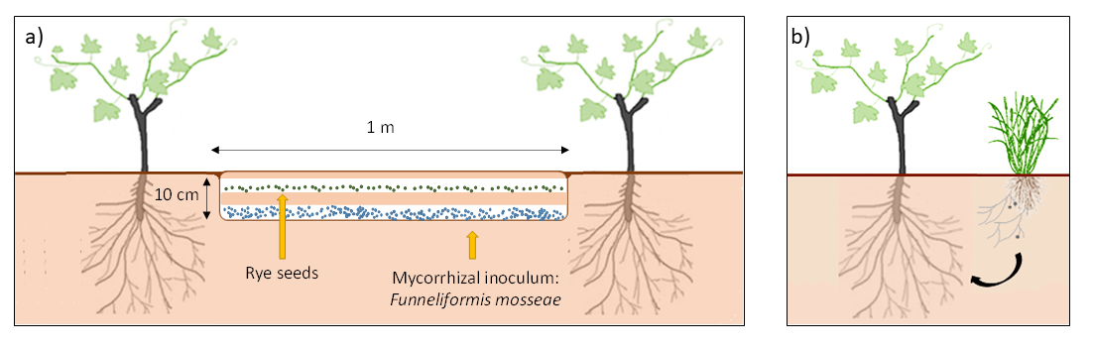
Fig. 2
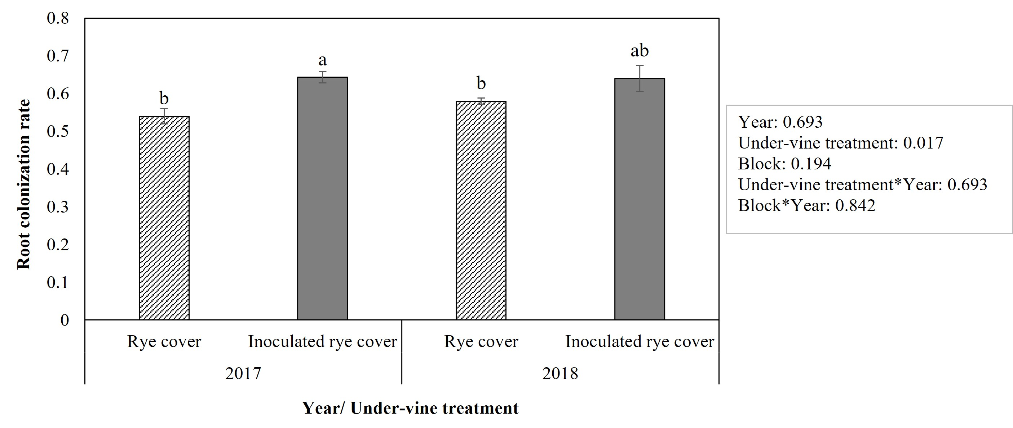

Fig. 3
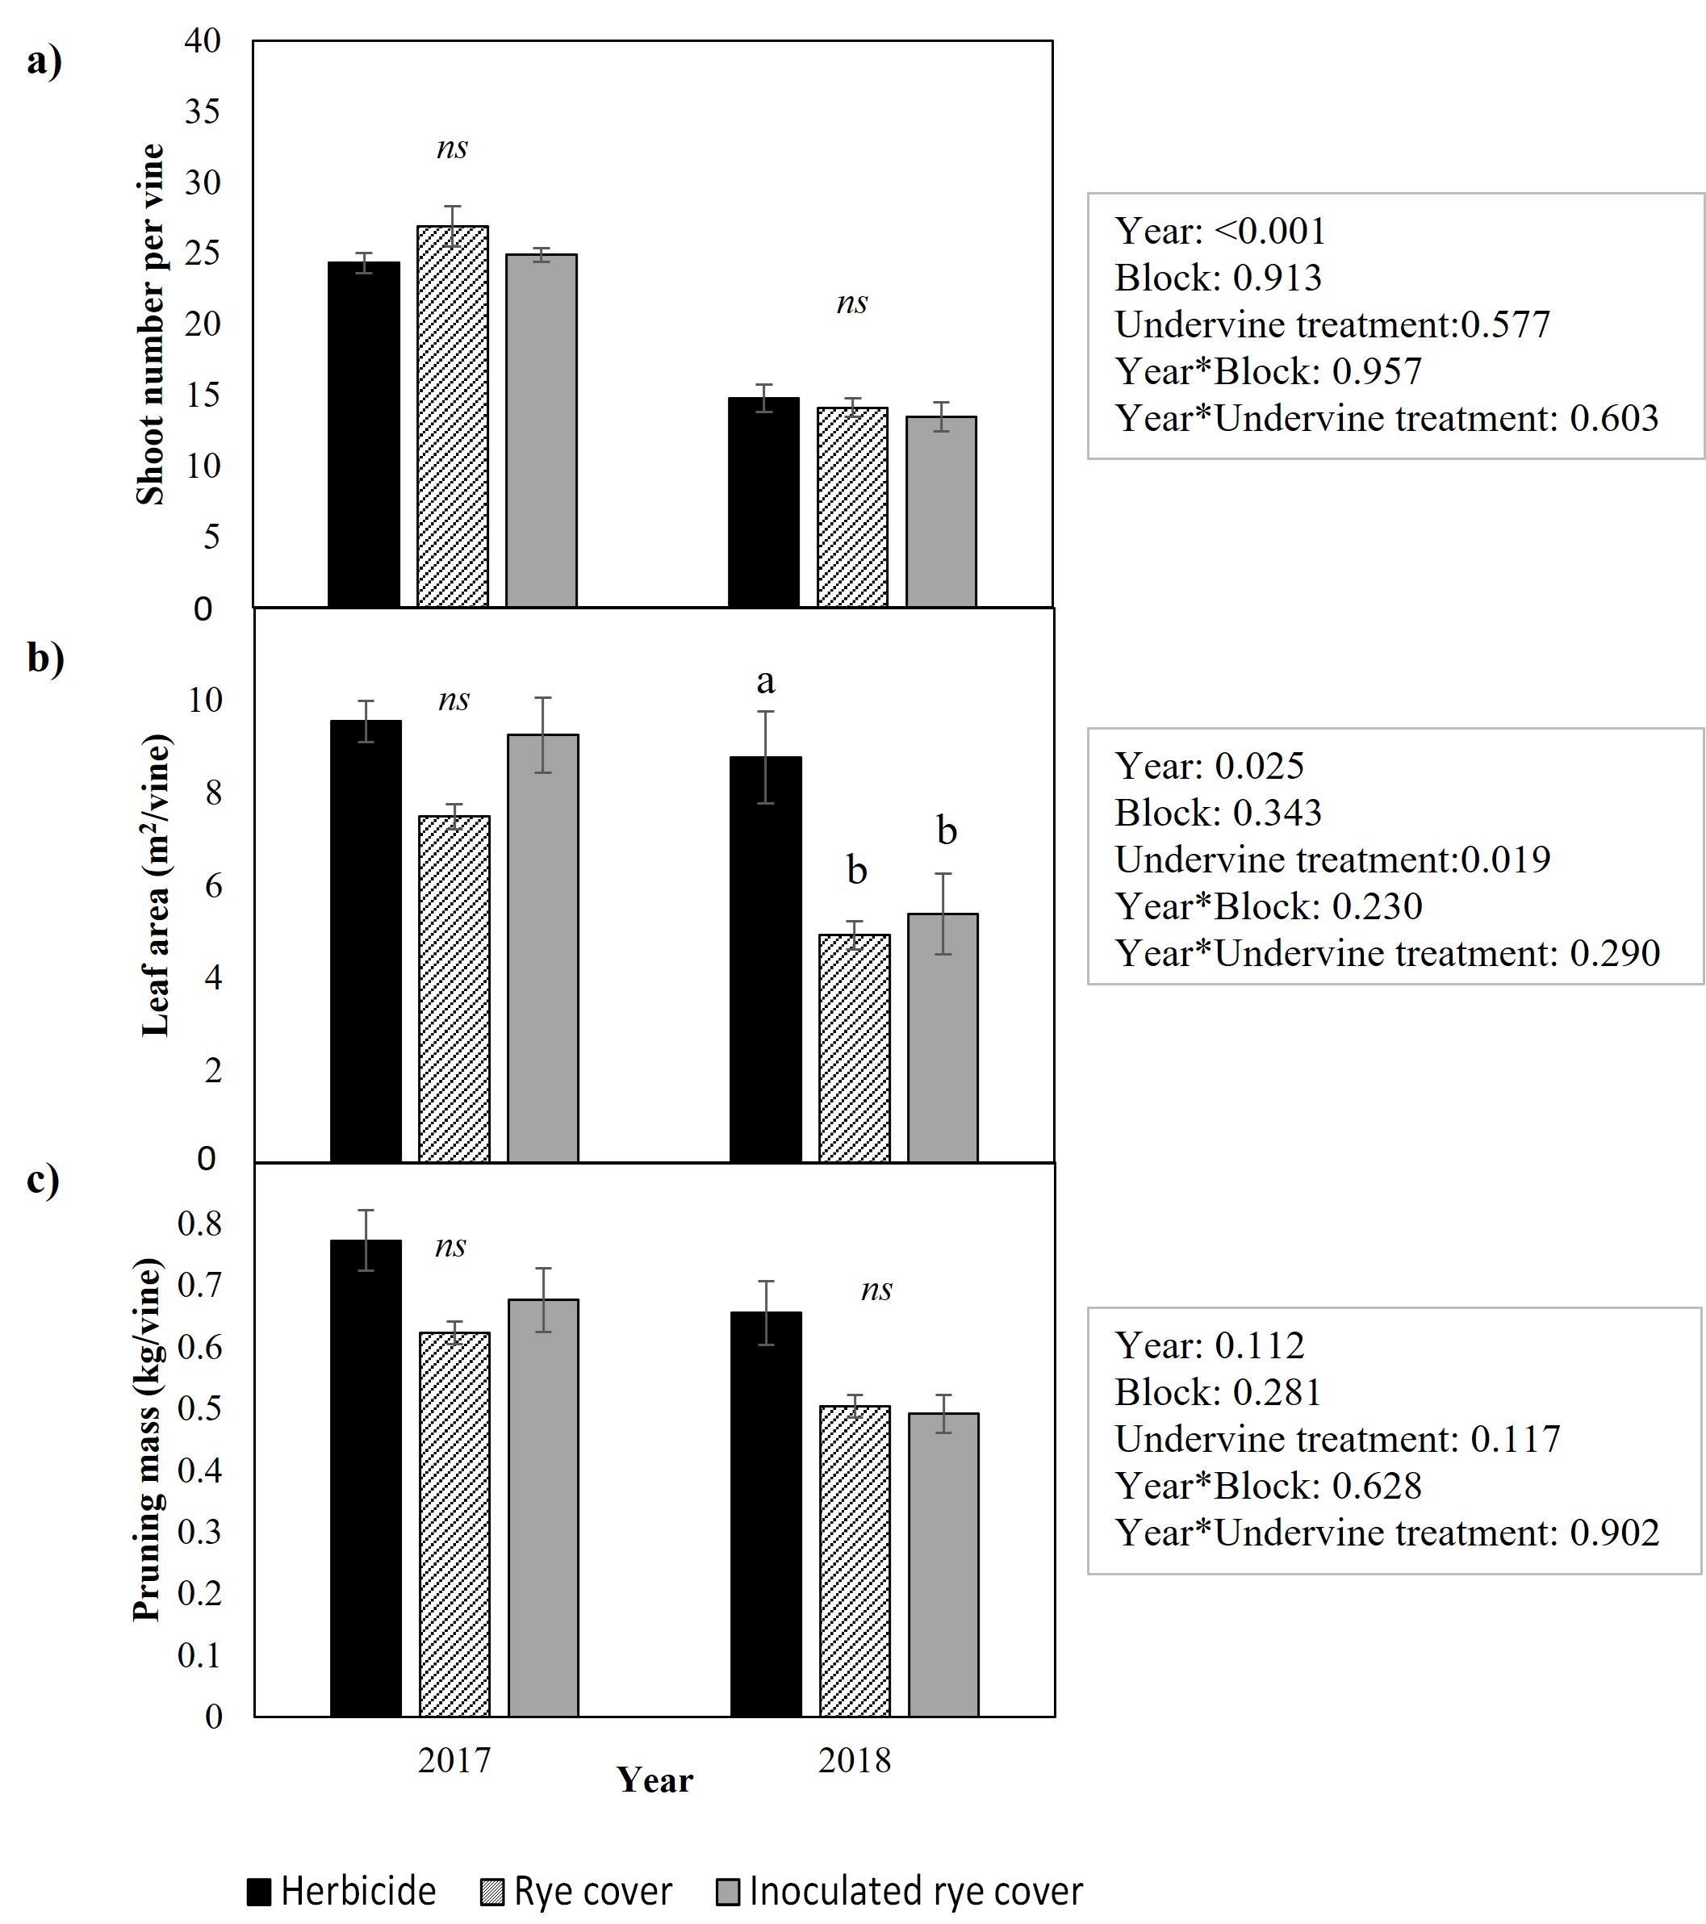

Fig. 4
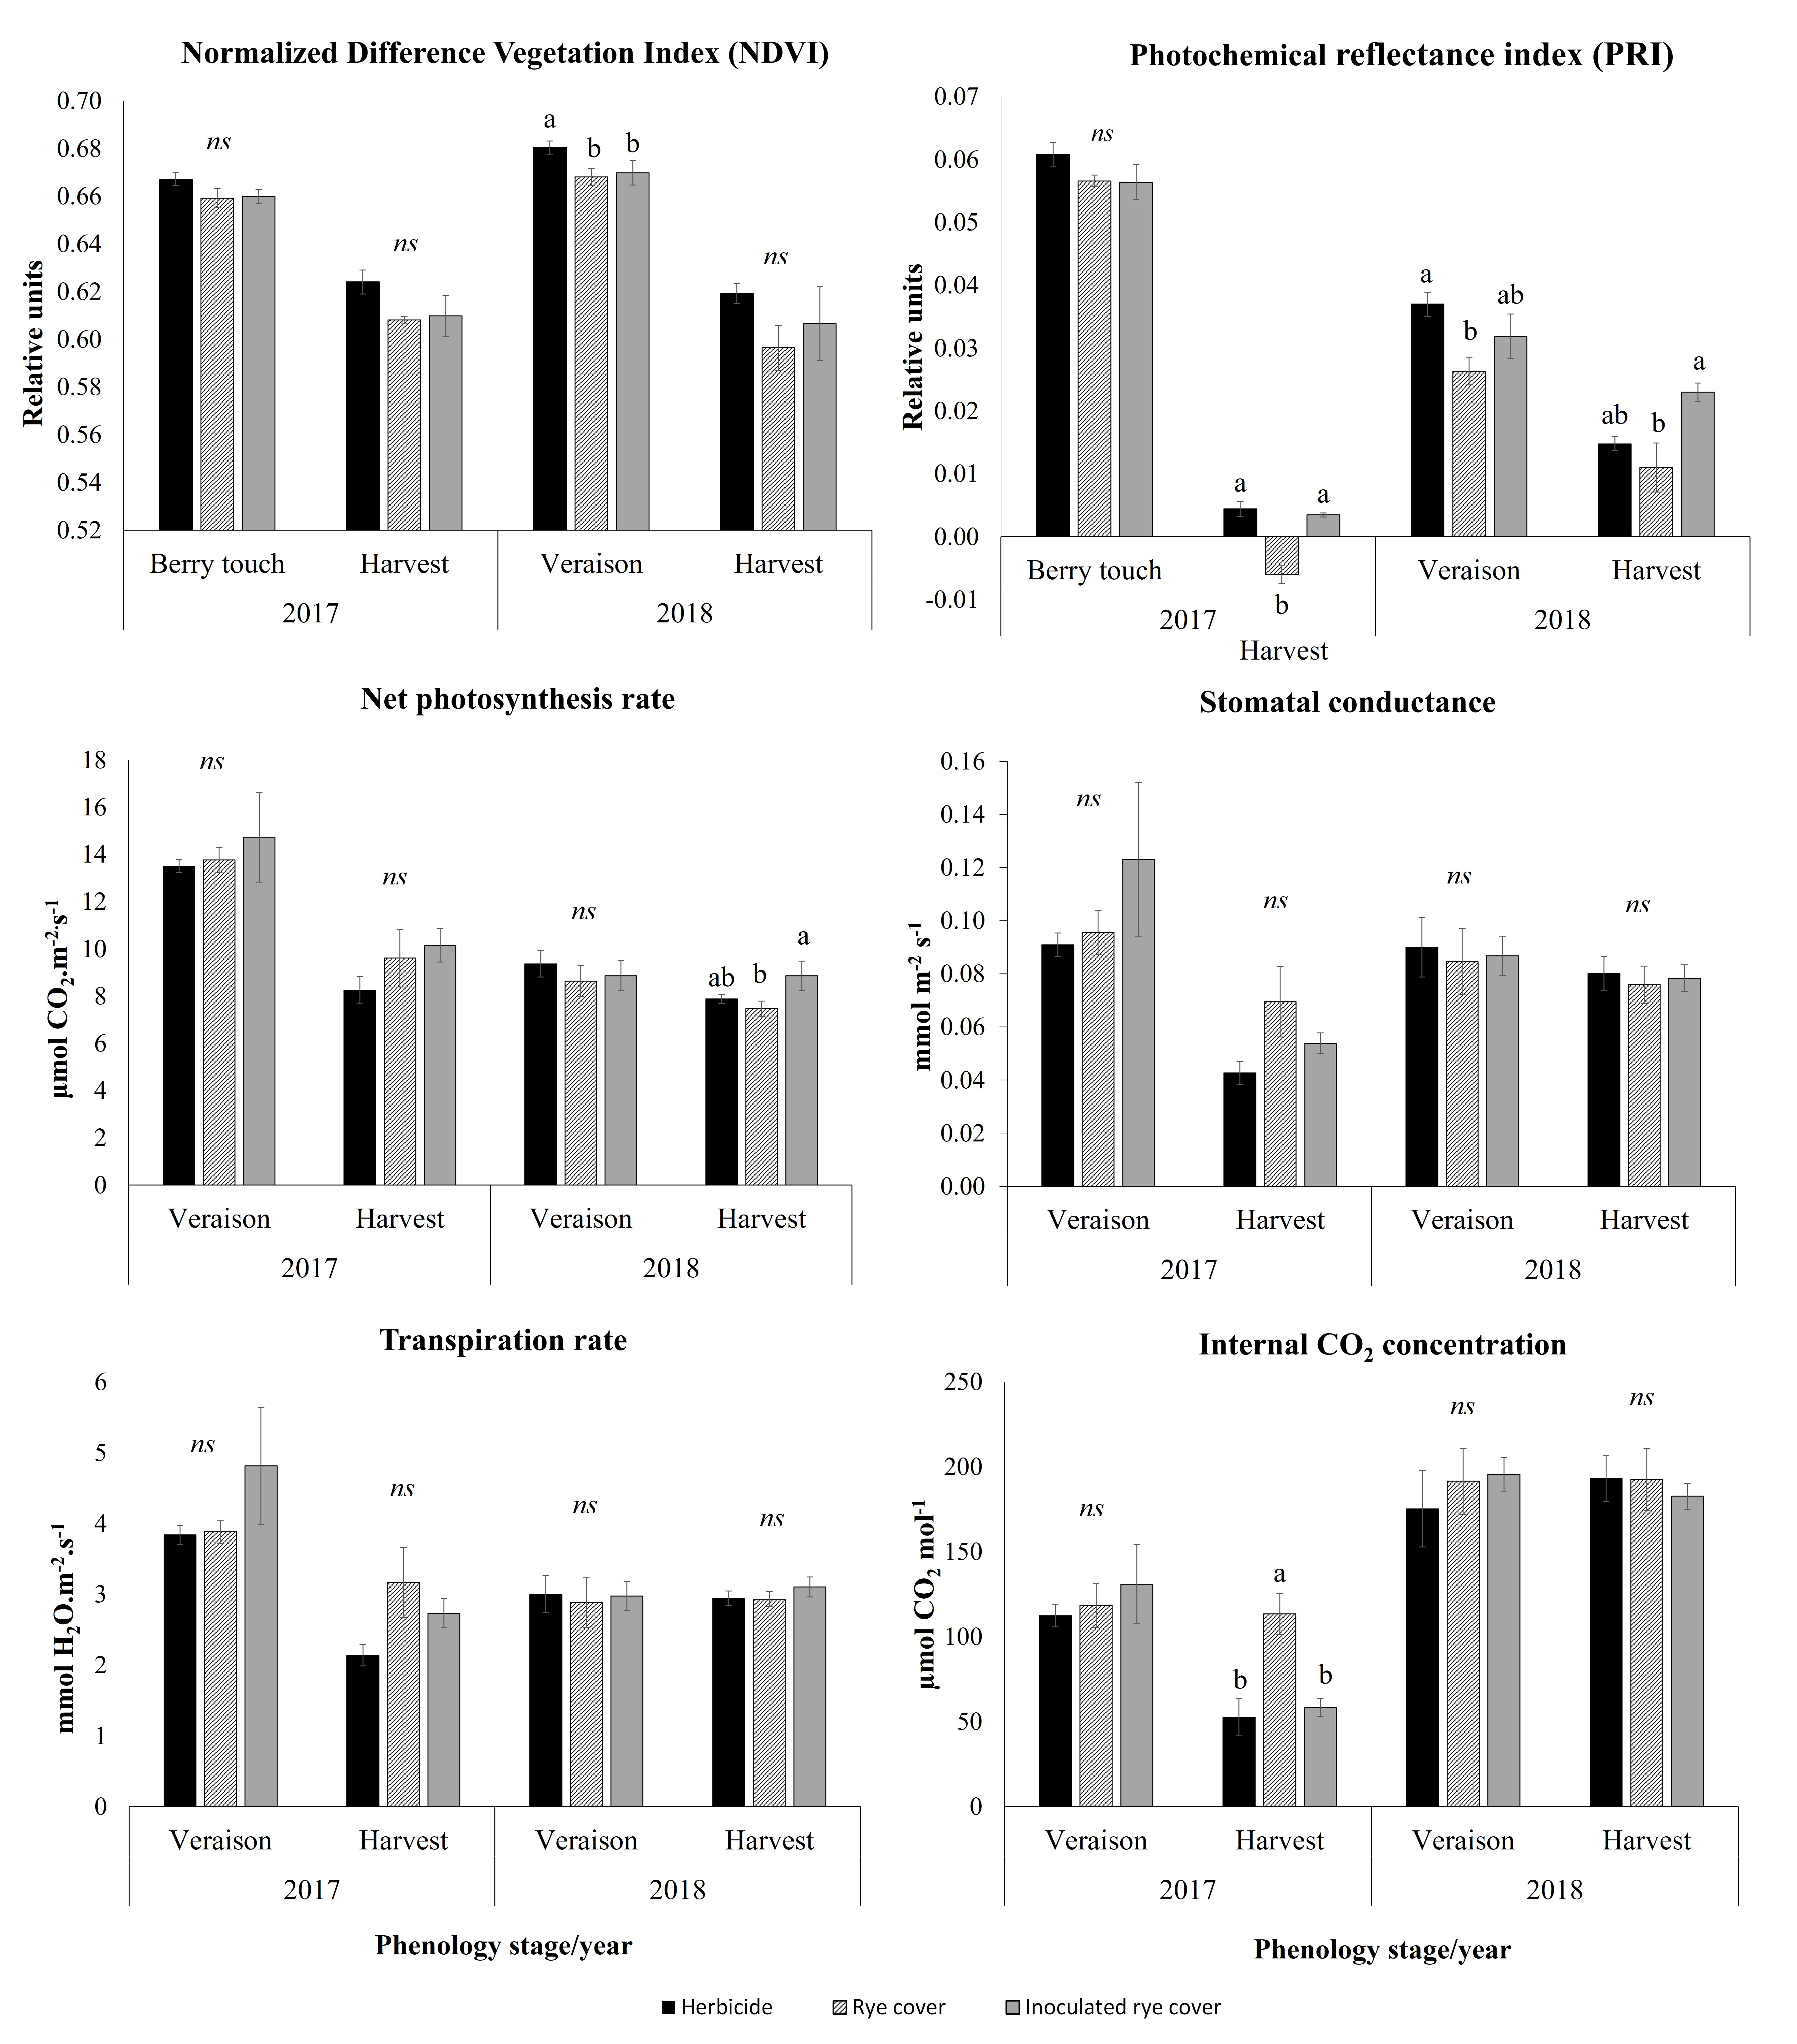

Fig. 5
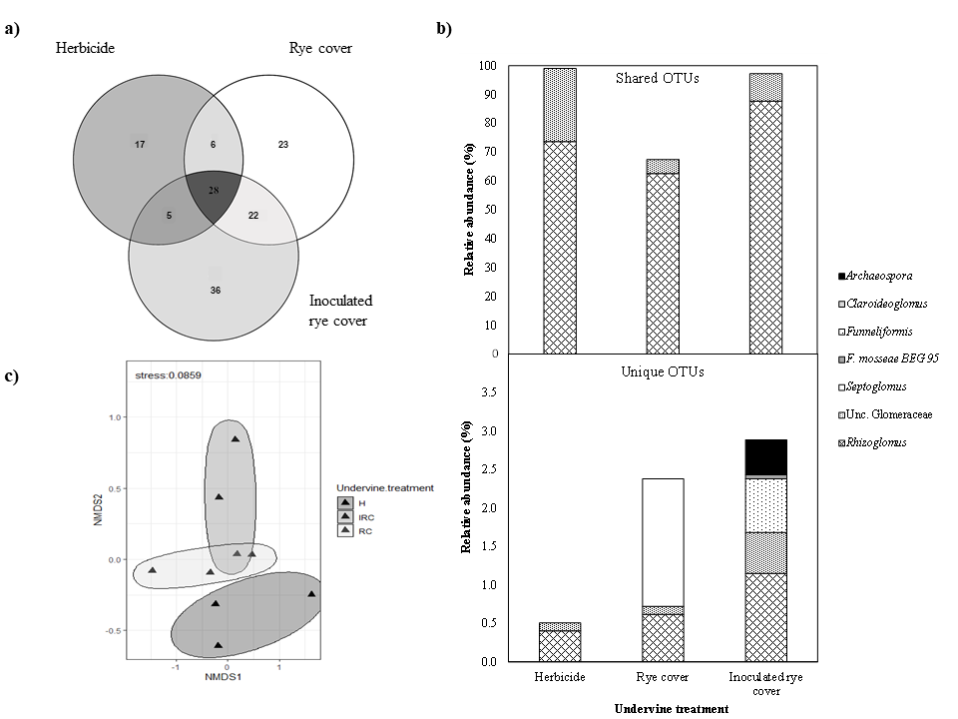

Fig. 6
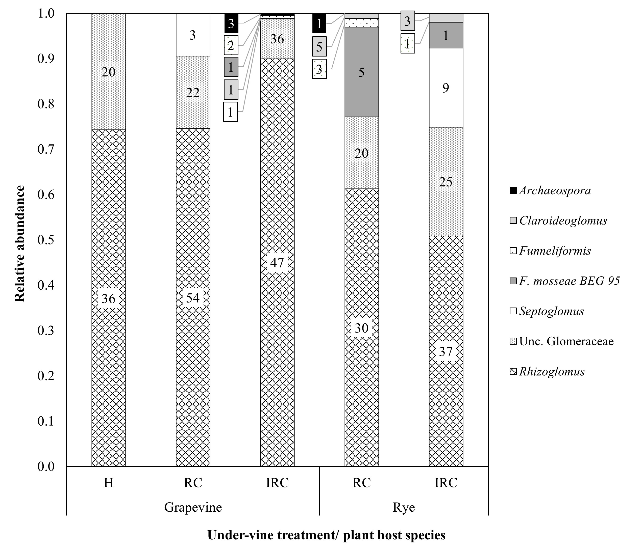

Fig. 7

