No evidence of inbreeding depression despite a historical severe bottleneck in the endangered Bermuda petrel (Pterodroma cahow)

Rita O. Afonso¹, Francisco Pina-Martins¹, Vicki Friesen², Zhengxin Sun², Letizia Campioni³, Jeremy Madeiros⁴, Mónica C. Silva^{1,*}

Afiiliations
¹ cE3c – Centre for Ecology, Evolution and Environmental Changes & CHANGE - Global Change and Sustainability Institute Departamento de Biologia Animal, Faculdade de Ciências, Universidade de Lisboa, 1749-016 Lisboa, Portugal
²Department of Biology, Queen’s University, Kingston, ON, K7L 3N6, Canada
³MARE – Marine and Environmental Sciences Centre, Ispa – Instituto Universitário, Rua Jardim do Tabaco 34, 1149-041 Lisboa, Portugal
⁴Department of Environment and Natural Resources, Bermuda

*Corresponding author: mssilva@fc.ul.pt

Keywords
ddRADseq, population genomics, hatching success, HFCs, Pterodroma ?
Abstract
The Bermuda petrel Pterodroma cahow is an island endemic seabird that belongs to the Procellariiformes, one of the most endangered orders of birds. Historical records suggest a significant population size decline following human settlement in Bermuda, bringing the species to near extinction. Since the 1950’s the population has been recovering aided by the implementation of an ongoing conservation plan. However, it still faces several threats, and negative genetic effects resulting from that drastic decline are to be expected, including inbreeding and genetic drift.
We studied genetic diversity and levels of inbreeding, and their effects on individual fitness and mating choice. We also tested for a genetic signature of the recent demographic bottleneck. For this, we analysed variation in thousands of nuclear single nucleotide polymorphisms derived from double digest restriction site associated DNA sequencing and one mitochondrial gene (cytochrome oxidase I).
The results revealed that the Bermuda petrel suffered a recent genetic bottleneck and shows low mitochondrial diversity compared to other petrel species. Conversely, nuclear diversity was similar to that of other endangered petrels. Inbreeding levels were not high overall, although some individuals were highly inbred. However, we found no evidence that individual inbreeding or relatedness between couples affected hatching success, or that mate choice is influenced by kinship in this very small population.
Introduction
A critical topic in conservation biology concerns the prevalence of inbreeding in small and isolated populations, particularly those restricted to islands, since it can have profound consequences on the viability of such populations. Mating between close relatives leads to a genome-wide increase of homozygosity in the offspring, a consequence of most alleles being identical-by-descent (IBD). The increase of homozygosity at loci carrying recessive deleterious alleles, or decrease in heterozygosity at loci with heterozygote advantage, has a negative impact on individual fitness, known as inbreeding depression (Charlesworth & Charlesworth, 1999). Individual heterozygosity (ideally averaged over many loci) has been frequently used as proxy for inbreeding (Townsend & Jamieson 2013) and when significantly correlated with fitness components (such as breeding success or survival) may indicate the presence of inbreeding depression. The impact of inbreeding depression on wild populations is still not well understood (Kardos et al. 2016), as it remains challenging to measure individual inbreeding levels in natural populations due to lack of accurate pedigrees or, until recently, the availability of a sufficiently large panel of markers to estimate genome-wide heterozygosity (Huisman et al. 2016).
A significant correlation of heterozygosity across loci (i.e., identity disequilibrium (ID)) will provide an indication of whether any heterozygosity-fitness correlations (HFCs) detected in a population may be caused by inbreeding depression (Kardos et al., 2014; Szulkin et al., 2010). HFCs can be driven by genome-wide heterozygosity (“general effect”) when ID is present in the population or by specific loci that are under selection and directly influence fitness (“local effect”) (Szulkin et al., 2010).
Demographic history can influence variation in genome-wide heterozygosity in a population, especially in scenarios of severe genetic drift, bottlenecks, and admixture (Szulkin et al., 2010). A population bottleneck is a likely cause of inbreeding depression since it usually involves a drastic reduction of population size when genetic drift is most powerful, and inbreeding is expected. This causality has been established in several endangered avian species (Blanco & Morinha, 2021; Dierickx et al., 2020; Townsend & Jamieson, 2013). Population bottlenecks may be particularly critical in single island endemics which will not receive an influx of genetic variation through gene flow when compared to continental or less isolated populations (e.g. Wang et al. 2017).
Several behaviours can help to reduce the negative fitness effects of inbreeding, such as kinship dis-assortative mating (Leedale et al., 2020; Levy et al., 2020) or extra-pair paternities (EPPs) in social monogamous species (Brouwer & Griffith, 2019). Also, deleterious mutations may be purged from populations by selection (Boakes et al., 2007; Hedrick & Garcia-Dorado, 2016), while others may be lost by chance (or fixed) by genetic drift. These processes may help a population recover from a period of severe inbreeding depression, but are usually difficult to detect in natural population due to concurrent adaptative processes (Boakes et al., 2007).
Monitoring the effects of inbreeding and outbreeding in avian natural populations is challenging because pedigrees are seldom available (Kardos et al., 2016), and researchers have relied on indirect measures of inbreeding by estimating the effect of individual heterozygosity on fitness (Szulkin et al., 2010). High throughput sequencing (HTS) technologies have had a very large impact in this endeavour. The ability to survey thousands of markers across the genome increased the reliability and consequently the power to study evolutionary processes in wild populations (Stapley et al., 2010). Specifically, reduced representation sequencing methods such as double digest restriction site associated DNA sequencing (ddRAD-seq) have allowed extraordinary improvements in the accuracy of key parameters such as relatedness (Lemopoulos et al., 2019; Thrasher et al., 2018), inbreeding and genome-wide heterozygosity compared to older tools like microsatellites (Hoffman et al., 2014; Huisman et al., 2016). Since pedigrees are difficult to obtain for natural populations, molecular marker-based measures of individual inbreeding (F) are the best alternative and comprise a range of methods depending on the type of markers employed. Advanced methods that map loci against a reference genome are the most informative since they allow identification of IBD chromosome segments, characterized by long runs of homozygosity (ROH) that arise from matings between relatives (Kardos et al., 2016). Even unmapped, thousands of single nucleotide polymorphisms (SNPs) obtained by techniques such as ddRADseq can accurately estimate F, using the diagonal elements of a genomic relatedness matrix (F_{GRM}) (Huisman et al., 2016; Kardos et al., 2016). Individual heterozygosity has also been proposed as an estimator of F, and multi-locus heterozygosity (MLH), the proportion of genotyped loci that are heterozygous, is often considered an estimator of genome-wide heterozygosity when derived from a high number of SNPs (e.g. Hoffman et al. 2014). Thus, a large number of genomic SNPs is critical to detect HFCs in small natural populations, which frequently lack a solid reference genome (Kardos et al., 2016).
In this study, we used ddRADseq to infer inbreeding by estimating genome-wide heterozygosity and its putative impacts in a very small, bottlenecked population of the endangered Bermuda petrel (Pterodroma cahow). The Bermuda petrel is a seabird species endemic to Bermuda, in the western North Atlantic Ocean (Figure 1). Like many other members of the Procellariiformes, one of the most endangered orders of birds (Dias et al., 2019), the Bermuda petrel was driven to near extinction by the arrival of humans to its breeding grounds. Although sub-fossil evidence and historical records suggest that the Bermuda petrel was abundant in the 16th century, direct persecution by humans, exotic predator species such as rats and hogs, and habitat destruction led to the disappearance of the Bermuda petrel by the 17th century. The species was thought to be extinct for three centuries. In 1951 a few pairs were found breeding on a small islet, and the population size has been increasing subsequently due to an ambitious conservation plan (Gehrman, 2012). Currently, the population comprises ~ 155 couples that breed on six small islets off Castle Harbour (Figure 1). Thus, the bottleneck caused by human arrival to the islands is relatively recent and is estimated to have lasted around 15 generations. Bermuda petrels are socially monogamous, and females lay a single egg clutch per year, which demands extensive biparental investment. The documented demographic history of the Bermuda petrel (see also Lawrence et al. 2008; Groombridge et al. 2009) as well as the close monitoring of the current breeding population, makes it an ideal model to test the impacts of a severe population reduction on genetic diversity and inbreeding in natural populations (Bortoluzzi et al., 2020; Cammen et al., 2018). Petrels are long-lived birds (up to 30 years old) (J. L. Madeiros, 2005), with an estimated generation time of 20 years (Nadachowska-Brzyska et al., 2015). Here, we aimed to identify genetic signatures of the recent bottleneck by estimating both genome-wide and mitochondrial DNA diversity, as well inferring the population’s demographic history, using SNPs isolated with a ddRAD-seq approach. We also estimated individual inbreeding levels and pair relatedness and tested their putative impacts on fitness. We estimated fitness from hatching success, which is low in the Bermuda petrel (67%) and one of the lowest for Pterodroma petrel species (Figure 2). Additionally, we tested the influence of relatedness on mate choice as an inbreeding avoidance strategy.

Material and Methods
Bermuda petrel hatching success
The Bermuda petrel population has been monitored annually since 1962 (J. Madeiros et al., 2012) in the context of the species recovery programme (https://environment.bm/cahow-recovery-programme). Most individuals are ringed as chicks, and a few are ringed when they start visiting the breeding colonies, at ca. 5 years of age. Data are collected for each of the ~ 155 active nests, including the identity of the two breeding adults, hatching and fledging success.

Sample collection and DNA extraction
Blood samples were collected from 104 Bermuda petrel breeding adults from 5 of the 6 islands where the species currently breeds (Figure 1). Samples were obtained in the 2019 and 2020 breeding seasons and stored at 4ºC in the field, then at -20ºC until DNA extraction. Samples were collected under license from the Department of Environment and Natural Resources, Government of Bermuda (License nr. 19-12-04-87 and 22-01-10-97).
Genomic DNA was isolated using the QIAGEN DNeasy Blood and Tissue Kit following the manufacturer’s protocol. The quality of the extracted DNA was checked with 1% agarose gel electrophoresis and a NanoDrop Microvolume Spectrophotometer (Thermo Fisher Scientific, Wilmington, DE, USA). DNA concentrations were measured using a Qubit 2.0 Fluorometer (Life Technologies).

Mitochondrial DNA genotyping
A 659 base-pair (bp) fragment of the cytochrome oxidase I gene (COI) was amplified for 53 individuals using primers F1B 5′-AACCGATGACTATTYTCAACC-3′ and
R1B 5′-TACTACRTGYGARATGATTCC-3’ (Gangloff et al., 2012). Polymerase chain reactions (PCR) were carried out in a final volume of 15 μl and contained 2 μl of dNTPs (266 μM), 1.5 μl of reaction buffer (1 X), 8.05 μl of nuclease free water, 0.25 μl of Taq polymerase (0.083 U/μl), 0.3 μl of each primer (0.2 μM), 0.6 μl of MgCl2 (2mM) and 2 μl of the DNA template. PCRs were performed in BioRad Thermocycler under the following conditions: first denaturation step of 3 min at 94ºC; 35 cycles, each one comprising a 94ºC step for 40s, primer-specific annealing temperature for 40s and an extension step at 72ºC for 80s; and a final extension step of 72ºC during 10 min. PCR products were visualized in 1% agarose gels. The successfully amplified products were purified using an ExoSap purification protocol. The amplified fragments were Sanger sequenced in both directions at Macrogen Inc. (Madrid, Spain).
Raw sequences were aligned and edited in Sequencher v. 5.4.6 (Gene Codes Corporation). SNPs were identified by visual assessment of the chromatograms.

ddRADseq genotyping
Library preparation and sequencing
Sequencing libraries were prepared at Queen’s University (Canada). DNA was double digested using SbfI and MluCI restriction enzymes and ligated with custom individual adapters including a degenerated base region (DBR). DNA fragments were size selected (350-600 bp) using BluePippin and amplified through 12-cycle PCR (Polymerase Chain Reaction). The DNA concentration of each sample was quantified using qPCR quantitative Polymerase Chain Reaction (qPCR) and pooled in equimolar proportions (45 fmol) for sequencing across one lane of Ilumina HiSeq 250, in Molecular core facility, Department of Biology, Queen’s University, Kingston, Canada.

De novo assembly
Raw reads were parsed to remove PCR duplicates using a Python script (Python Software Foundation, https://www.python.org/, available at https://github.com/Eljensen/ParseDBR_ddRAD, commit: 8fc0edc, which was run under Python 3.5.4), which removes duplicates by detecting identical DBR adaptors between reads. Duplicate-free data was processed using FastQC v0.11.9 (www.bioinformatics.babraham.ac.uk/projects/fastqc/) for quality assessment. The Stacks v. 2.55 (Catchen et al., 2013) module process_radtags was used to demultiplex the reads and to discard reads with uncalled bases and low-quality scores.
Due to the absence of a reference genome for the species, a de novo assembly approach of the aligned reads was conducted using Stacks denovo_map pipeline, by building a reference catalogue of all loci identified. Parameters for the loci and catalogue building were optimized following the approach described in Paris et al. (2017). The minimum depth of coverage required to form an allele (or a stack) was set to m=3, the maximum number of mismatches allowed between stacks to form a locus was set to M=3, and the maximum number of mismatches allowed between sequences of different individuals to be considered the same locus was set to n=3.

Variant calling and filtering
Following catalogue building, identified variants were filtered. Two datasets were created according to downstream analyses. The Stacks module populations and the software VCFTools v. 0.1.16 (Danecek et al., 2011) were used to filter any SNPs that may reflect genotyping errors. Loci present in less than 60% of the individuals, and SNPs with more than 60% observed heterozygosity and less than 5% of the minor allele frequency (MAF) were removed from the data set. Sites that had more than 20% missing data or that significantly deviated from Hardy-Weinberg equilibrium (p-value < 0.05) were also excluded from the dataset. VCFTools was used to obtain the distribution of the mean depth of coverage per locus (DP) across all individuals, and SNPs with less than 0.25X of the median depth (DP=10X) or more than 2X of the median depth (DP=80X) were removed. This dataset was designated “all_snp” (Table S1). Since certain analyses can be impacted by linkage disequilibrium, a filter selecting only the SNP closest to the centre of each RAD locus was applied using vcf_parser.py Python script (as of commit 0e96c2c, available at https://github.com/CoBiG2/RAD_Tools), resulting in the “one_snp” dataset (Table S1). PGDSpider v. 2.1.1.5 (Lischer & Excoffier, 2012) was used to convert these datasets to appropriate file formats based on downstream analyses.

Relatedness inference
The GNU R package related v. 1.0 (Pew et al., 2015), based on the algorithm by Wang 2011 as implemented in the COANCESTRY software, was used to estimate relatedness (r) between all pairs of individuals. The function compareestimators was applied to test the performance of different genomic relatedness estimators on simulated data. This function creates simulated pairs of individuals of known relationship (e.g. parent-offspring, full-siblings) derived from the allele frequencies provided in the real dataset, and tests the correlation between observed and expected data. The Wang 2002 estimator was determined to perform best with our dataset based on 1000 simulated pairs of each degree of relatedness. The coancestry function was then used to estimate r between pairs of individuals using a random subsample of 4000 SNPs. The accuracy of the chosen genomic estimator using ddRAD data was checked against kinship data collected in the field.

Inbreeding avoidance though assortative mating
To test for inbreeding avoidance, the mean relatedness of 31 breeding pairs present in the dataset was compared with the frequency distributions of 31 simulated couples, with one male and one female taken randomly with replacement from the dataset of 104 individuals. Significance was testing using non-parametric bootstrapping with 1000 simulations and α= 0.05. Principal component analysis (PCA) of the “one_snp” dataset was used to infer any possible sub-structuring of the population, which might also suggest non-random mating. The PCA was performed using the R package SNPRelate v. 1.24.0 (Zheng et al., 2012) as implemented in the R script snp_pca_static.R (https://github.com/CoBiG2/RAD_Tools, commit: a69e9bd).

Inbreeding inference
The ddRAD dataset was used to infer individual inbreeding (F) using the diagonal elements of a genomic relatedness matrix (F_{GRM}) (VanRaden, 2008) implemented in GCTA software (Yang et al., 2011). Such estimate has been described as a viable indicator of inbreeding when only unmapped loci are available (Huisman et al., 2016; Kardos et al., 2016). We also computed individual multi-locus heterozygosity (MLH) in the GNU R package inbreedR v. 0.3.2 (Stoffel et al., 2016), which approximates the proportion of the heterozygous loci across the genome; MLH is described as a function of f (Crow & Kimura, 1970), and usually used as its surrogate.

Heterozygosity-fitness correlations
The impact of inbreeding on fitness was estimated by testing for a significant heterozygosity-fitness correlation (HFC) using hatching success as a fitness trait. HFC will only arise in a population if inbreeding coefficients vary among individuals, which can be determined by evaluating the identity disequilibrium (ID), the correlation of heterozygosity across loci. The ID was estimated from the distribution of MLH in our dataset, estimating the parameter g₂ (David et al. 2007) using the inbreedR package. The probability that g₂ differs from 0, indicating no variance in inbreeding, was computed with 1000 permutations to estimate the p-value and 1000 bootstraps to estimate a 95% confidence interval.
The impact of mating between relatives on hatching success was tested for the 31 pairs using a generalized linear mixed model (GLMM) using the R package lme4 v. 1.1-27.1 (Bates et al., 2015). Hatching success was set as the response variable, pairwise relatedness as the fixed effect and nest-ID as a random effect. The individual inbreeding impact on hatching success was also tested using a GLMM model. The MLH of 62 individuals was used (members of the 31 couples) as a fixed effect, nest-ID as a random effect and hatching success as the response variable. GLMMs were conducted using the R lme4 package.

Genetic diversity
Standard polymorphism statistics were estimated for the COI gene fragment in DnaSP v.6 (Rozas et al. 2003) including the number of segregating sites (S), number of haplotypes (H), and haplotype and nucleotide diversities (H_{d}, π). Genetic diversity measures were also estimated for the “all_snp” dataset using the populations module of Stacks. Nucleotide diversity was estimated for every variable site (π_{SNP}) and for the RAD loci of the Stacks’ catalogue (π_{RAD}). Mean per-individual observed and expected heterozygosities (H_{o} and H_{e}) were also estimated.

Demographic history inference
The demographic history of the Bermuda petrel was investigated by two approaches, both based on the site frequency spectrum (SFS). The folded SFS was calculated with easySFS (https://github.com/isaacovercast/easySFS, commit: b866269), using a third dataset without missing data, MAF and maximum heterozygosity filters were not applied and all SNPs per RAD locus were included.
First, Stairway plot v.2 (Liu & Fu, 2020) was used, a software that fits a multi-epoch demographic model to the data. We tested four random breakpoints (51, 103, 154, 206) based on the sample size. As recommended, 67% of sites were used for training the data, and 200 bootstraps to estimate 95% confidence intervals. We used a mutation rate of 2.89 x 10⁻⁹ per site per generation based on an estimate for the northern fulmar (Fulmarus glacialis) (Nadachowska-Brzyska et al., 2015). The generation time of the Bermuda petrel was estimated to be 20 years (Nadachowska-Brzyska et al., 2015).
The second approach was implemented under a fast, continuous-time sequential Markovian coalescent approximation in fastsimcoal v. 2.7 (Excoffier et al., 2021). Three different models were compared: “Recent Bot”, “Null” and “Old Bot”. The “Null” model assumes a constant population size over time (Figure 3). The “Recent Bot” model tests the likelihood of a genetic bottleneck from 3 to 30 generations ago, while “Old Bot” simulated an older bottleneck between 30 and 200 000 generations ago (Figure 3). For each model, 100 independent runs were performed with 30 cycles and 100 000 coalescent simulations to estimate an expected SFS. The best run for each model was found through the highest likelihood, as implemented in fsc-selectbestrun.sh script (https://github.com/speciationgenomics/scripts, commit: 48a9fb2). The fit of each model was analysed by comparing the observed and expected SFS, using the utilFscOutput.r R script (https://github.com/vsousa/EG_cE3c/blob/master/CustomScripts/Fastsimcoal_ProcessOutput/Scripts_AnalyseFsc, commit: c3a8871). The most suitable model to our dataset was assessed by the Akaike information criterion (AIC), which incorporates the number of parameters of the model, using calculateAIC.sh script (https://github.com/speciationgenomics/scripts, commit: 48a9fb2).

Results
COI genotyping
We sequenced 689 bp (without gaps) of the COI gene for 53 Bermuda petrel individuals, which include a single polymorphic site defining 2 haplotypes.

Sample processing
The ddRAD library produced 403 387 152 raw reads. Demultiplexing and quality filtering in Stacks resulted in 399 838 435 usable reads. Further filtering and SNP extraction resulted in two datasets with a different number of variable sites: an “all snp” dataset with 33 501 SNPs; and an “one_snp” dataset with 12 484 SNPs (Table S1). No individuals were excluded, and the final datasets consisted of 104 individuals.

Population structure
Population structure analysis in P. cahow as revealed by a PCA showed no evidence of sub-structure between the islands where individuals currently breed (Figure S2).

Inbreeding and relatedness inference
Estimates of the inbreeding coefficient as calculated by the genomic relatedness matrix (F_{GRM}) ranged from -0.093 to 0.24, with a mean value of -0.017 (Figure 4). F_{GRM} can take negative values, because the current population is used as reference, thus an individual with a negative F_{GRM} is outbred compared to the mean of the population (Huisman et al., 2016). Multi-locus heterozygosity (MLH) estimates ranged between 0.21 and 0.33 (mean of 0.294). Three individuals showed lower heterozygosity values, below 0.25 (Figure S1). MLH and F_{GRM} were highly correlated (Pearson’s coefficient r=-0.93, P =2.2e-16). Thus, MLH estimates were used for further analyses related to heterozygosity fitness correlations.
Mean relatedness of the 31 breeding pairs was 0.020 (SD = 0.131). Three pairs showed very high relatedness: two had values of 0.177 and 0.258, which may represent pairings between cousins and half-siblings, respectively. The third had a relatedness value of 0.557, and field data confirmed it is a full-sibling couple. We consider that the relatedness coefficients estimated for our dataset reflects reliable biological information since the estimates for known related individuals were as expected (Figure S3).

Inbreeding depression: HFCs
Evidence of identity disequilibrium (ID) was found in the Bermuda petrel ddRAD dataset, as the parameter g2, although not high, was significantly different from zero (0.0046, P < 0.001). This result indicates that heterozygosity is significantly correlated across loci among the 62 individuals, and that heterozygosity is representative of genome wide heterozygosity, which makes its use valid to test for general effect HFCs (Szulkin et al., 2010). No significant effect of the MLH on individual hatching success was found, among the 62 individuals (Table 1). Parental relatedness also failed to predict offspring hatching success (Table 1).

Inbreeding avoidance: assortative mating
The mean value of pairwise relatedness of the 31 pairs sampled did not significantly differ from the relatedness of the simulated pairs generated by the non-parametric bootstrap procedure (P > 0.05) (Figure 5). Hence, results provide no evidence that individuals are choosing mates that are more or less genetically related to themselves than if chosen at random.

Patterns of genetic diversity
Standard genetic diversity measures for mtDNA (COI) and the ddRADseq data differed.
Nucleotide diversity in the COI gene was extremely low, π=0.027 x 10⁻² - the lowest COI of any Pterodroma species studied to date (Table 2). Nucleotide diversity obtained using only polymorphic sites (π_{SNP}) from the ddRADseq analysis of 104 individuals was 0.193, while the nucleotide diversity based on the entire RAD locus (π_{RAD}) was 0.197 x 10⁻², two orders of magnitude lower than π_{SNP}, as expected. Observed and expected heterozygosities (Ho, He) also were two orders of magnitude lower when all loci were included (Table 3).

Demographic history
Data filtering applied to the dataset used to estimate the SFS resulted in 27 062 SNPs present in all 104 individuals. Stairway Plot analysis revealed a slow and prolonged decrease in effective population size, from ~150 000 individuals about 100 000 years ago to ~4 000individuals 2 000 year ago, suggesting a reduction of ~98% (Figure 6). Following this prolonged decrease, the analysis suggests a sharper population decline in Ne (from 4 000 to 600 individuals) that lasted around 1 200 years followed by an apparent short recovery in the subsequent 300 years.
The “Recent bot” model showed the highest likelihood in fastsimcoal2, followed by the “Old bot”, showing a slightly lower likelihood, and finally the “Null” model (Table S2). The “Recent bot” model suggests a ~99.8 % populations reduction between 13 and 3 generations ago, followed by a ~90% expansion. Generally, the model suggests that the current Ne is ~98.3% lower than before the bottleneck. Despite this model showing the best fit for our data, the fit to the observed SFS is not very good (Figure S5).

Discussion
Evidence of a recent genetic bottleneck
Genetic diversity analyses and demographic history inference of the island endemic Bermuda petrel using both the COI gene and a high-throughput sequencing approach allowed us to detect a signature of a recent genetic bottleneck of the population. Although historical records refer to a drastic population size decline due to the human arrival to Bermuda in the 17th century (Gehrman, 2012), we could not associate the genetic bottleneck precisely to that time period. Still, anthropogenic influences have irrefutably impacted this species’ demographic history.
We found that the Bermuda petrel shows higher RAD nucleotide diversity than expected from such a small population. Although it is hard to compare estimates of diversity between species, the Bermuda petrel shows relatively higher RAD genetic diversity compared to other island avian species, such as the New Zealand hihi (Notiomystis cincta) (de Villemereuil et al., 2019), the Cape Verde raso lark (Alauda razae) (Dierickx et al., 2020), or the endangered Hawaiian Band-rumped Storm Petrel (Hydrobates castro) (Antaky et al., 2020). The nucleotide diversity of the polymorphic sites of the Bermuda petrel was also higher than some non-endangered seabird species, such as the Black-footed albatrosses (Phoebastria albatrus) (Kuro-o et al., 2010) and the thick-billed murres (Uria lomvia and U. aalge) (Tigano, 2016), although lower than the diversity of the abundant Leach’s storm petrel (Hydrobates leucorhous) (Sin et al., 2021). Conversely, mitochondrial diversity for the Bermuda petrels was extremely low, with only one polymorphic site among 53 individuals. In fact, Bermuda petrels show the lowest nucleotide and haplotype diversity of the COI locus among seven endangered, Pterodroma species, some of which having undergone recent severe bottlenecks (Lawrence et al. 2016; Tizard et al. 2019). A conflicting signal between the mtDNA and ddRAD estimates of diversity might be because the mtDNA, due to its smaller Ne, will track the demographic history of populations faster than will nuclear loci. The recency of the bottleneck (around 3.5 generations ago) as well as the short, estimated duration of the bottleneck (around 15 generations) and the remarkable population growth that followed, may have prevented a serious loss of genetic diversity in the nuclear genome.
Both inferences of demographic history suggest a recent contraction from a larger ancestral population size. Stairway Plot results showed a clear prolonged population size decrease starting in the last 100 000 years ago, which coincides with the late Pleistocene, characterized by severe sea-level fluctuations due to global glaciation cycles. At that time, the Bermuda Islands endured a drastic area reduction during sea level highs (Harmon et al., 1978), which may have severely limited habitat availability for breeding Bermuda petrels. In fact, fossil records suggest the extinction of at least two other seabird species in Bermuda around that time: the Short-tailed Albatross Phoebastria albatrus and a species of shearwater Calonectris wingatei (Olson, 2008). Furthermore, the Stairway Plot analysis suggests a much sharper effective population size (Ne) decline, earlier than one might expect for a potential population bottleneck driven by the arrival of the first humans to Bermuda (Gehrman, 2012). However, this discrepancy might be explained by the fact that current methods of demographic inference based on the SFS derived from RADseq data may not provide accurate estimates of the timing of such recent demographic events (Santiago et al., 2020). This is related to the low number of coalescent events in a relatively short timeframe, particularly for species with high generation times like the Bermuda petrel. A drastic decline of the species could have started before human arrival due to other factors, such as environmental events, that were later compounded by the human arrival to the islands.
The steep Ne increase that followed the more recent bottleneck may not represent an actual population expansion. Because the coalescence rate is very high during a genetic bottleneck, coalescence between lineages is almost null after the bottleneck ends (Hamilton, 2009).

Lack of evidence of inbreeding and inbreeding depression
The thousands of SNP markers obtained with high-throughput sequencing techniques allow us to infer population inbreeding levels and their influence on fitness with a superior resolution than what was previously possible. This is particularly important for non-model species that lack a solid pedigree (Kardos et al., 2016). Unexpectedly, we found low inbreeding levels in the sampled Bermuda petrels (equivalent to ca. a third of all the breeding population) and a low mean inbreeding coefficient. However, we found evidence of inbreeding variance as demonstrated by the estimate of identity disequilibrium. Although all the individuals sampled in this study were adults, and this metric may decrease with age due to selection against inbred individuals (Huisman et al., 2016), g2 was still significantly different from 0, which suggests that heterozygosity assessed through sequencing ddRAD loci is representative of the Bermuda petrel population’s genome-wide heterozygosity. It also suggests that genome-wide heterozygosity correlates with individual inbreeding and that heterozygosity-fitness correlations (HFCs) may exist in the population, caused by a genome-wide effect (Szulkin et al., 2010). Assessment of HFCs in small populations like the Bermuda petrel is key to understanding the effects of inbreeding on different fitness components. Several avian species show a strong effect of inbreeding on fertility and hatchability, as well as on other fitness traits (Hemmings et al., 2012; Marr et al., 2006; Trask et al., 2021). High levels of inbreeding can lead to genetic incompatibility between mates that result in hatching failure, due to early embryo death (Hemmings et al., 2012). Despite its recorded low hatching success, we found no influence of individual inbreeding on hatching success in the Bermuda petrel. Additionally, we found no effect of relatedness between mates on hatching success. This pattern may be explained by the low number of highly related pairs in our dataset, or possibly by the occurrence of extra-pair paternities (EPPs). Although poorly explored in Pterodroma, EPPs have been described in other Procellariiformes (Bried et al., 2021) and have been flagged as a potential mechanism of inbreeding avoidance (Brouwer & Griffith, 2019) (but see Mays et al. 2008). Other possible causes of low hatching success in the Bermuda petrel may be maternal and/or environmental factors (Hemmings et al., 2012). Although our results failed to detect HFC regarding hatching success, the significant identity disequilibrium in our dataset suggests that inbreeding might be affecting fitness. Other fitness related traits should be considered in the future, as well as thorough sampling of chicks and juveniles to better understand the impact of inbreeding and to test the presence of inbreeding depression more accurately in the Bermuda petrel population.
Species with highly restricted ranges and highly philopatric, such as the Bermuda petrel, have limited dispersal strategies, which may lead individuals to rely on inbreeding avoidance behaviour. Assortative mating is known to reduce mating between relatives. Procellariiform species are thought to be able to differentiate kin from non-kin through olfactory cues (Bonadonna & Sanz-Aguilar, 2012). Additionally, in genetically monogamous species with obligate biparental care, selection on mate choice is expected to be strong (Nava et al., 2017). However if the pool of available mates is limited, it may be more beneficial to pair with a less compatible mate than to forego reproduction in a given year. Alternatively, Bermuda petrels may not be able to recognize relatives. Also, other characteristics may be more important than genome-wide relatedness during mate choice, such as certain phenotypic traits, behaviours, or similarity at specific functional genes. Hence, we cannot conclude that assortative mating is not a strategy to mitigate inbreeding depression in the Bermuda petrel only based on neutral genomic variation and degree of kinship. Regions of the genome that highly impact fitness, such as those related to the immune function, should also be assessed to fully understand the relation between inbreeding and mating behaviour.
Bottlenecked populations are expected to show elevated inbreeding due to reduced mate availability (Hasselgren et al., 2021; Osborne et al., 2016). However, the unexpected lack of inbreeding and inbreeding depression has been recorded in other species (Botero-Delgadillo et al., 2020; Laws & Jamieson, 2011; Wen et al., 2021), including the iconic island fox, Urocyon littoralis, (Robinson et al., 2018). These unexpected results for the Bermuda petrel may be explained by the purging by natural selection of highly deleterious alleles over a severe inbreeding period, as proposed for other wild species (Laws & Jamieson, 2011; Robinson et al., 2018). Although purging maybe more effective when inbreeding occurs for long periods of time at low rates (Hedrick & Garcia-Dorado, 2016), is still a plausible explanation due to the long period of small population size in the demographic history of the Bermuda petrel. Also, the relatively short duration of the bottleneck relative to the long generation time of Bermuda petrels may have contributed to the remarkable recovery and lack of inbreeding depression in this population.
This study helps to understand the Bermuda petrel demographic history, and contemporary inbreeding. Further studies are needed to fully understand both the extent and the consequences of the recent demographic bottleneck suffered by this population.

Data availability
Funding
This study was supported by Fundação para a Ciência e a Tecnologia (FCT; Portugal) through a project granted to cE3c (UIDB/BIA/00329/2020) and by project PTDC/BIA-EVL/28565/2017. MCS is funded by FCT through a contract foreseen in DL 57/2016, changed by Law 57/2017. The computational resources needed for this study were partially made available by Infraestrutura Nacional de Computação Distribuida (INCD) through the FCT project CPCA_A0_7297_2020.

Acknowledgments
We thank Matilde Silva for sequencing the COI gene.
References
Antaky, C. C., Conklin, E. E., Toonen, R. J., Knapp, I. S. S., & Price, M. R. (2020). Unexpectedly high genetic diversity in a rare and endangered seabird in the Hawaiian Archipelago. PeerJ, 2020(2), 1–18. https://doi.org/10.7717/peerj.8463
Bartle, J. A. (1968). Observations on the breeding habits of Pycroft’s petrel. Notornis, 15(70:99).
Bates, D., Mächler, M., Bolker, B. M., & Walker, S. C. (2015). Fitting linear mixed-effects models using lme4. Journal of Statistical Software, 67(1). https://doi.org/10.18637/jss.v067.i01
Bester, A. J., Priddel, D., Klomp, N. I., Carlile, N., & O’Neill, L. E. (2007). Reproductive success of the Providence Petrel Pterodroma solandri on Lord Howe Island, Australia. Marine Ornithology, 35(1), 21–28.
Blanco, G., & Morinha, F. (2021). Genetic signatures of population bottlenecks, relatedness, and inbreeding highlight recent and novel conservation concerns in the Egyptian vulture. PeerJ, 9. https://doi.org/10.7717/peerj.11139
Boakes, E. H., Wang, J., & Amos, W. (2007). An investigation of inbreeding depression and purging in captive pedigreed populations. Heredity, 98(3), 172–182. https://doi.org/10.1038/sj.hdy.6800923
Bonadonna, F., & Sanz-Aguilar, A. (2012). Kin recognition and inbreeding avoidance in wild birds: The first evidence for individual kin-related odour recognition. Animal Behaviour, 84(3), 509–513. https://doi.org/10.1016/j.anbehav.2012.06.014
Bortoluzzi, C., Bosse, M., Derks, M. F. L., Crooijmans, R. P. M. A., Groenen, M. A. M., & Megens, H. J. (2020). The type of bottleneck matters: Insights into the deleterious variation landscape of small managed populations. Evolutionary Applications, 13(2), 330–341. https://doi.org/10.1111/eva.12872
Botero-Delgadillo, E., Quirici, V., Vásquez, R. A., & Kempenaers, B. (2020). Heterozygosity-Fitness Correlations in a Continental Island Population of Thorn-Tailed Rayadito. Journal of Heredity, 111(7), 628–639. https://doi.org/10.1093/jhered/esaa056
Bried, J., Andris, M., Dubois, M. P., & Jarne, P. (2021). Decreased selectivity during mate choice in a small-sized population of a long-lived seabird. Journal of Avian Biology, 1–13. https://doi.org/10.1111/jav.02837
Brouwer, L., & Griffith, S. C. (2019). Extra-pair paternity in birds. Molecular Ecology, 28(22), 4864–4882. https://doi.org/10.1111/mec.15259
Cammen, K. M., Vincze, S., Heller, A. S., McLeod, B. A., Wood, S. A., Bowen, W. D., Hammill, M. O., Puryear, W. B., Runstadler, J., Wenzel, F. W., Kinnison, M., & Frasier, T. R. (2018). Genetic diversity from pre-bottleneck to recovery in two sympatric pinniped species in the Northwest Atlantic. Conservation Genetics, 19(3), 555–569. https://doi.org/10.1007/s10592-017-1032-9
Catchen, J., Hohenlohe, P. A., Bassham, S., Amores, A., & Cresko, W. A. (2013). Stacks: an analysis tool set for population genomics. Molecular Ecology, 22(11), 3124–3140. https://doi.org/10.1111/mec.12354.Stacks
Charlesworth, B., & Charlesworth, D. (1999). The genetic basis of inbreeding depression. Genetical Research, 74(3), 329–340. https://doi.org/10.1017/S0016672399004152
Crow, J. F., & Kimura, M. (1970). An introduction in Population Genetics Theory. Harper and Row, New York.
Cuthbert, R. (2004). Breeding biology of the Atlantic Petrel, Pterodroma incerta , and a population estimate of this and other burrowing petrels on Gough Island, South Atlantic Ocean. Emu - Austral Ornithology, 104(3), 221–228. https://doi.org/10.1071/mu03037
Danecek, P., Auton, A., Abecasis, G., Albers, C. A., Banks, E., DePristo, M. A., Handsaker, R. E., Lunter, G., Marth, G. T., Sherry, S. T., McVean, G., & Durbin, R. (2011). The variant call format and VCFtools. Bioinformatics, 27(15), 2156–2158. https://doi.org/10.1093/bioinformatics/btr330
David P, Pujol B, Viard F, Castella V, G. J. (2007). Reliable selfing rate estimates from imperfect population genetic data. Molecular Ecology, 16, 2474–2487.
de Villemereuil, P., Rutschmann, A., Lee, K. D., Ewen, J. G., Brekke, P., & Santure, A. W. (2019). Little Adaptive Potential in a Threatened Passerine Bird. Current Biology, 29(5), 889-894.e3. https://doi.org/10.1016/j.cub.2019.01.072
Dias, M. P., Martin, R., Pearmain, E. J., Burfield, I. J., Small, C., Phillips, R. A., Yates, O., Lascelles, B., Borboroglu, P. G., & Croxall, J. P. (2019). Threats to seabirds: A global assessment. Biological Conservation, 237(April), 525–537. https://doi.org/10.1016/j.biocon.2019.06.033
Dierickx, E. G., Wa Sin, S. Y., Van Veelen, P. J. H., De Brooke, L. M., Liu, Y., Edwards, S. V., & Martin, S. H. (2020). Genetic diversity, demographic history and neo-sex chromosomes in the Critically Endangered Raso lark. Proceedings of the Royal Society B: Biological Sciences, 287(1922). https://doi.org/10.1098/rspb.2019.2613
Excoffier, L., Marchi, N., Marques, D. A., Matthey-Doret, R., Gouy, A., & Sousa, V. C. (2021). Fastsimcoal2 : Demographic Inference Under Complex Evolutionary Scenarios . Bioinformatics, 37(24), 4882–4885. https://doi.org/10.1093/bioinformatics/btab468
Gangloff, B., Shirihai, H., Watling, D., Cruaud, C., Couloux, A., Tillier, A., Pasquet, E., & Bretagnolle, V. (2012). The complete phylogeny of Pseudobulweria, the most endangered seabird genus: Systematics, species status and conservation implications. Conservation Genetics, 13(1), 39–52. https://doi.org/10.1007/s10592-011-0261-6
Gehrman, E. (2012). Rare Birds: The Extraordinary Tale of the Bermuda Petrel and the Man Who Brought It Back from Extinction. Beacon Press, Boston.
Groombridge, J. J., Dawson, D. A., Burke, T., Prys-Jones, R., Brooke, M. de L., & Shah, N. (2009). Evaluating the demographic history of the Seychelles kestrel (Falco araea): Genetic evidence for recovery from a population bottleneck following minimal conservation management. Biological Conservation, 142(10), 2250–2257. https://doi.org/10.1016/j.biocon.2009.04.026
Gummer, H., Taylor, G., Wilson, K. J., & Rayner, M. J. (2015). Recovery of the endangered Chatham petrel (Pterodroma axillaris): A review of conservation management techniques from 1990 to 2010. Global Ecology and Conservation, 3, 310–323. https://doi.org/10.1016/j.gecco.2014.12.006
Hamilton, M. B. (2009). Genotype Frequencies. In Population Genetics. Wiley-Blackwell, Chichester, UK.
Harmon, R. S., Schwarcz, H. P., & Ford, D. C. (1978). Late Pleistocene sea level history of Bermuda. Quaternary Research, 9(2), 205–218. https://doi.org/10.1016/0033-5894(78)90068-6
Hasselgren, M., Dussex, N., von Seth, J., Angerbjörn, A., Olsen, R. A., Dalén, L., & Norén, K. (2021). Genomic and fitness consequences of inbreeding in an endangered carnivore. Molecular Ecology, 30(12), 2790–2799. https://doi.org/10.1111/mec.15943
Hedrick, P. W., & Garcia-Dorado, A. (2016). Understanding Inbreeding Depression, Purging, and Genetic Rescue. Trends in Ecology and Evolution, 31(12), 940–952. https://doi.org/10.1016/j.tree.2016.09.005
Hemmings, N., West, M., & Birkhead, T. R. (2012). Causes of hatching failure in endangered birds. Biology Letters, 8(6), 964–967. https://doi.org/10.1098/rsbl.2012.0655
Hoffman, J. I., Simpson, F., David, P., Rijks, J. M., Kuiken, T., Thorne, M. A. S., Lacy, R. C., & Dasmahapatra, K. K. (2014). High-throughput sequencing reveals inbreeding depression in a natural population. Proceedings of the National Academy of Sciences of the United States of America, 111(10), 3775–3780. https://doi.org/10.1073/pnas.1318945111
Huisman, J., Kruuk, L. E. B., Ellisa, P. A., Clutton-Brock, T., & Pemberton, J. M. (2016). Inbreeding depression across the lifespan in a wild mammal population. Proceedings of the National Academy of Sciences of the United States of America, 113(13), 3585–3590. https://doi.org/10.1073/pnas.1518046113
Imber, M. J., West, J. A., & Cooper, W. J. (2003). Cook’s petrel (Pterodroma cookii): Historic distribution, breeding biology and effects of predators. Notornis, 50(4), 221–230.
Kardos, M., Allendorf, F. W., & Luikart, G. (2014). Evaluating the role of inbreeding depression in heterozygosity-fitness correlations: How useful are tests for identity disequilibrium? Molecular Ecology Resources, 14(3), 519–530. https://doi.org/10.1111/1755-0998.12193
Kardos, M., Taylor, H. R., Ellegren, H., Luikart, G., & Allendorf, F. W. (2016). Genomics advances the study of inbreeding depression in the wild. Evolutionary Applications, 9(10), 1205–1218. https://doi.org/10.1111/eva.12414
Kuro-o, M., Yonekawa, H., Saito, S., Eda, M., Higuchi, H., Koike, H., & Hasegawa, H. (2010). Unexpectedly high genetic diversity of mtDNA control region through severe bottleneck in vulnerable albatross Phoebastria albatrus. Conservation Genetics, 11(1), 127–137. https://doi.org/10.1007/s10592-009-0011-1
Lawrence, H.A., Scofield, R.P., Taylor, G.A., Lyver, P.O.B. and Gleeson, D. M. (2016). Genetic, morphological and behavioural evidence supports the treatment of Grey-faced Petrel as a separate species, Pterodroma gouldi. Zoological Journal of the Linnean Society, 179(1), 201–216.
Lawrence, H. A., Taylor, G. A., Millar, C. D., & Lambert, D. M. (2008). High mitochondrial and nuclear genetic diversity in one of the world’s most endangered seabirds, the Chatham Island Taiko (Pterodroma magentae). Conservation Genetics, 9(5), 1293–1301. https://doi.org/10.1007/s10592-007-9471-3
Laws, R. J., & Jamieson, I. G. (2011). Is lack of evidence of inbreeding depression in a threatened New Zealand robin indicative of reduced genetic load? Animal Conservation, 14(1), 47–55. https://doi.org/10.1111/j.1469-1795.2010.00388.x
Leedale, A. E., Simeoni, M., Sharp, S. P., Green, J. P., Slate, J., Lachlan, R. F., Robinson, E. J. H., & Hatchwell, B. J. (2020). Cost, risk, and avoidance of inbreeding in a cooperatively breeding bird. Proceedings of the National Academy of Sciences of the United States of America, 117(27), 15724–15730. https://doi.org/10.1073/pnas.1918726117
Lemopoulos, A., Prokkola, J. M., Uusi-Heikkilä, S., Vasemägi, A., Huusko, A., Hyvärinen, P., Koljonen, M. L., Koskiniemi, J., & Vainikka, A. (2019). Comparing RADseq and microsatellites for estimating genetic diversity and relatedness — Implications for brown trout conservation. Ecology and Evolution, 9(4), 2106–2120. https://doi.org/10.1002/ece3.4905
Levy, H., Fiddaman, S. R., Vianna, J. A., Noll, D., Clucas, G. V., Sidhu, J. K. H., Polito, M. J., Bost, C. A., Phillips, R. A., Crofts, S., Miller, G. D., Pistorius, P., Bonnadonna, F., Le Bohec, C., Barbosa, A., Trathan, P., Rey, A. R., Frantz, L. A. F., Hart, T., & Smith, A. L. (2020). Evidence of pathogen-induced immunogenetic selection across the large geographic range of a wild seabird. Molecular Biology and Evolution, 37(6), 1708–1726. https://doi.org/10.1093/molbev/msaa040
Lischer, H. E. L., & Excoffier, L. (2012). PGDSpider: An automated data conversion tool for connecting population genetics and genomics programs. Bioinformatics, 28(2), 298–299. https://doi.org/10.1093/bioinformatics/btr642
Liu, X., & Fu, Y. X. (2020). Stairway Plot 2: demographic history inference with folded SNP frequency spectra. Genome Biology, 21(1), 1–9. https://doi.org/10.1186/s13059-020-02196-9
Madeiros, J., Carlile, N., & Priddel, D. (2012). Breeding biology and population increase of the Endangered Bermuda Petrel Pterodroma cahow. Bird Conservation International, 22(1), 35–45. https://doi.org/10.1017/S0959270911000396
Madeiros, J. L. (2005). Recovery plan for the Bermuda Petrel (Cahow) Pterodroma cahow. 90.
Marr, A. B., Arcese, P., Hochachka, W. M., Reid, J. M., & Keller, L. F. (2006). Interactive effects of environmental stress and inbreeding on reproductive traits in a wild bird population. Journal of Animal Ecology, 75(6), 1406–1415. https://doi.org/10.1111/j.1365-2656.2006.01165.x
Mays, H. L., Albrecht, T., Liu, M., & Hill, G. E. (2008). Female choice for genetic complementarity in birds: A review. Genetica, 134(1), 147–158. https://doi.org/10.1007/s10709-007-9219-5
Menezes, D., Oliveira, P., & Ramirez, I. (2010). Pterodromas do arquipélago da Madeira. Duas espécies em recuperação. Funchal, Portugal: Serviço do Parque Natural da Madeira.
Nadachowska-Brzyska, K., Li, C., Smeds, L., Zhang, G., & Ellegren, H. (2015). Temporal dynamics of avian populations during pleistocene revealed by whole-genome sequences. Current Biology, 25(10), 1375–1380. https://doi.org/10.1016/j.cub.2015.03.047
Nava, C., Neves, V. C., Andris, M., Dubois, M. P., Jarne, P., Bolton, M., & Bried, J. (2017). Reduced population size does not affect the mating strategy of a vulnerable and endemic seabird. Die Naturwissenschaften, 104(11–12), 103. https://doi.org/10.1007/s00114-017-1523-z
O’Dwyer, T. W., Buttemer, W. A., Priddel, D. M., & Downing, J. A. (2006). Prolactin, body condition and the cost of good parenting: An interyear study in a long-lived seabird, Gould’s Petrel (Pterodroma leucoptera). Functional Ecology, 20(5), 806–811. https://doi.org/10.1111/j.1365-2435.2006.01168.x
Olson, S. L. (2008). A new species of shearwater of the genus Calonectris (Aves: Procellariidae) from a middle Pleistocene deposit on Bermuda. Proceedings of the Biological Society of Washington, 121(3), 398–409. https://doi.org/10.2988/08-11.1
Osborne, A. J., Negro, S. S., Chilvers, B. L., Robertson, B. C., Kennedy, M. A., & Gemmell, N. J. (2016). Genetic evidence of a population bottleneck and inbreeding in the endangered New Zealand sea lion Phocarctos hookeri. Journal of Heredity, 107(5), 392–402. https://doi.org/10.1093/jhered/esw015
Paris, J. R., Stevens, J. R., & Catchen, J. M. (2017). Lost in parameter space: a road map for stacks. Methods in Ecology and Evolution, 8(10), 1360–1373. https://doi.org/10.1111/2041-210X.12775
Pew, J., Muir, P. H., Wang, J., & Frasier, T. R. (2015). related: An R package for analysing pairwise relatedness from codominant molecular markers. Molecular Ecology Resources, 15(3), 557–561. https://doi.org/10.1111/1755-0998.12323
Robinson, J. A., Brown, C., Kim, B. Y., Lohmueller, K. E., & Wayne, R. K. (2018). Purging of Strongly Deleterious Mutations Explains Long-Term Persistence and Absence of Inbreeding Depression in Island Foxes. Current Biology, 28(21), 3487-3494.e4. https://doi.org/10.1016/j.cub.2018.08.066
Rozas J, Sanchez-DelBarrio JC, Messeguer X, R. R. (2003). DnaSP, DNA polymorphism analyses by the coalescent and other methods. Bioinformatics, 19, 2496–2497.
Santiago, E., Novo, I., Pardiñas, A. F., Saura, M., Wang, J., & Caballero, A. (2020). Recent demographic history inferred by high-resolution analysis of linkage disequilibrium. Molecular Biology and Evolution, 37(12), 3642–3653. https://doi.org/10.1093/molbev/msaa169
Sin, S. Y. W., Hoover, B. A., Nevitt, G. A., & Edwards, S. V. (2021). Demographic history, not mating system, explains signatures of inbreeding and inbreeding depression in a large outbred population. American Naturalist, 197(6), 658–676. https://doi.org/10.1086/714079
Stapley, J., Reger, J., Feulner, P. G. D., Smadja, C., Galindo, J., Ekblom, R., Bennison, C., Ball, A. D., Beckerman, A. P., & Slate, J. (2010). Adaptation genomics: The next generation. Trends in Ecology and Evolution, 25(12), 705–712. https://doi.org/10.1016/j.tree.2010.09.002
Stoffel, M. A., Esser, M., Kardos, M., Humble, E., Nichols, H., David, P., & Hoffman, J. I. (2016). inbreedR: an R package for the analysis of inbreeding based on genetic markers. Methods in Ecology and Evolution, 7(11), 1331–1339. https://doi.org/10.1111/2041-210X.12588
Szulkin, M., Bierne, N., & David, P. (2010). Heterozygosity-fitness correlations: A time for reappraisal. Evolution, 64(5), 1202–1217. https://doi.org/10.1111/j.1558-5646.2010.00966.x
Thrasher, D. J., Butcher, B. G., Campagna, L., Webster, M. S., & Lovette, I. J. (2018). Double-digest RAD sequencing outperforms microsatellite loci at assigning paternity and estimating relatedness: A proof of concept in a highly promiscuous bird. Molecular Ecology Resources, 18(5), 953–965. https://doi.org/10.1111/1755-0998.12771
Tigano, A. (2016). From Genes to Genomes: Local Adaptation and Adaptive Potential in Two Arctic Seabirds. Queen’s University.
Tizard, J., Patel, S., Waugh, J., Tavares, E., Bergmann, T., Gill, B., Norman, J., Christidis, L., Scofield, P., Haddrath, O., Baker, A., Lambert, D., & Millar, C. (2019). DNA barcoding a unique avifauna: An important tool for evolution, systematics and conservation. BMC Evolutionary Biology, 19(1), 1–13. https://doi.org/10.1186/s12862-019-1346-y
Townsend, S. M., & Jamieson, I. G. (2013). Molecular and pedigree measures of relatedness provide similar estimates of inbreeding depression in a bottlenecked population. Journal of Evolutionary Biology, 26(4), 889–899. https://doi.org/10.1111/jeb.12109
Trask, A. E., Ferrie, G. M., Wang, J., Newland, S., Canessa, S., Moehrenschlager, A., Laut, M., Duenas, L. B., & Ewen, J. G. (2021). Multiple life-stage inbreeding depression impacts demography and extinction risk in an extinct-in-the-wild species. Scientific Reports, 11(1), 1–10. https://doi.org/10.1038/s41598-020-79979-4
VanRaden, P. M. (2008). Efficient methods to compute genomic predictions. Journal of Dairy Science, 91(11), 4414–4423. https://doi.org/10.3168/jds.2007-0980
Wang, E., Van Wijk, R. E., Braun, M. S., & Wink, M. (2017). Gene flow and genetic drift contribute to high genetic diversity with low phylogeographical structure in European hoopoes (Upupa epops). Molecular Phylogenetics and Evolution, 113, 113–125. https://doi.org/10.1016/j.ympev.2017.05.018
Wang, J. (2002). An estimator for pairwise relatedness using molecular markers. Genetics, 160(3), 1203–1215. https://doi.org/10.1093/genetics/160.3.1203
Wang, J. (2011). Coancestry: A program for simulating, estimating and analysing relatedness and inbreeding coefficients. Molecular Ecology Resources, 11(1), 141–145. https://doi.org/10.1111/j.1755-0998.2010.02885.x
Wen, G., Jin, L., Wu, Y., Wang, X., Fu, J., & Qi, Y. (2021). Low diversity, little genetic structure but no inbreeding in a high-density island endemic pit-viper Gloydius shedaoensis. Current Zoology, October, 1–9. https://doi.org/10.1093/cz/zoab084
Yang, J., Lee, S. H., Goddard, M. E., & Visscher, P. M. (2011). GCTA: A tool for genome-wide complex trait analysis. American Journal of Human Genetics, 88(1), 76–82. https://doi.org/10.1016/j.ajhg.2010.11.011
Zheng, X., Levine, D., Shen, J., Gogarten, S. M., Laurie, C., & Weir, B. S. (2012). A high-performance computing toolset for relatedness and principal component analysis of SNP data. Bioinformatics, 28(24), 3326–3328. https://doi.org/10.1093/bioinformatics/bts606

List of Tables

Table 1 - Results of the generalized linear mixed models (GLMM). The dependent variable is presented first and the fixed effect after, while the random effect is in parenthesis.
Table 2 - Nucleotide and haplotype diversity for the COI mitochondrial gene of seven Pterodroma species. N represents the number of sampled individuals and H the number of haplotypes.
Table 3 - Pterodroma genetic diversity indices based on ddRAD sequencing for the Bermuda petrel and the closely related, and equally endangered Zino’s petrel and Desertas petrel.

List of Figures

Figure 1. Location of Bermuda Islands including two insets. The red areas on the second inset are the current breeding areas of the Bermuda petrel, located among five islands labelled by their initials. NS - Nonsuch; GI - Green Island; HR - Horn Rock; IP – Inner Pear; LR – Long Rock; CA – Castle Harbour.
This map was created using ArcGIS® software by Esri. ArcGIS® and ArcMap™ are the intellectual property of Esri and are used herein under license. Copyright © Esri. All rights reserved. For more information about Esri® software, please visit www.esri.com.

Figure 2. Hatching success of ten Gadfly petrel species, all belonging to the genus Pterodroma. The Bermuda petrel is highlighted in red and bold. Pterodroma axillaris (Gummer et al., 2015); P. cookii (Imber et al., 2003); P. pycrofti (Bartle, 1968); P. magentae (Imber et al., 2003); P. madeira (Menezes et al., 2010); P. leucoptera (O’Dwyer et al., 2006); P. cahow (present study); P. incerta (Cuthbert, 2004); P. deserta (Menezes et al., 2010); P.a solandri (Bester et al., 2007).

Figure 3. Historical demographic models analysed using fastsimcoal2. Model names are on top of each scheme. NCUR represents the estimation for current Ne; NANC, Ne before the bottleneck; and NBOT, Ne during the bottleneck. TBOT defines the time (in generations) passed since the end of the bottleneck, while TENDBOT identifies the beginning

Figure 4. The genomic coefficient of inbreeding (F_{GRM})distribution of the 104 sampled individuals. The black vertical line is relative to the mean value. The red vertical lines correspond to reference values of F_{GRM}.

Figure 5. Distribution of relatedness (r) between mates of randomly generated couples. The vertical solid line represents the mean value. The dashed line represents the mean value of pairwise relatedness for the 31 sampled pairs of Bermuda petrel. Darkened areas of the density plot represent α = 0. 025.

Figure 6. Stairway Plot analysis results. The Bermuda petrel’s generation time was set as 20 years. All axes are presented in logarithmic scale

Table 1

Model | N | Estimate ± SE | p
hatching success ~ MLH + (1|nest id) | 62 | 1.38 ± 6.57 | 0.834
hatching success ~ relatedness + (1|nest id) | 31 | -0.54 ± 1.53 | 0.723
MLH – multi locus heterozygosity; SE – standard error; p – p-value.

Table 2

 | Variable sites |  |  | All sites
Species | π_{SNP} | Ho | He | π_{RAD} (x 10²) | Ho (x 10²) | He (x 10²)
Pterodroma cahow | 0.193 | 0.180 | 0.187 | 0.197 | 0.183 | 0.191
Pterodroma deserta | 0.181 | 0.180 | 0.175 | 0.176 | 0.173 | 0.171
Pterodroma madeira | 0.202 | 0.182 | 0.196 | 0.200 | 0.180 | 0.194

Table 3

Scientific name | Common name | N | Fragment size (bp) | Polymorphic sites / 100bp | Nucleotide diversity  (π x 10²) | H | Haplotype diversity (H_{d})
P. cahow | Bermuda petrel | 53 | 689 | 0.145 | 0.022 | 2 | 0.142
P. deserta | Desertas petrel | 53 | 732 | 0.41 | 0.071 | 3 | 0.470
P. madeira | Zino’s petrel | 53 | 732 | 2.32 | 0.286 | 7 | 0.764
P. feae | Cape Verde petrel | 53 | 732 | 0.956 | 0.133 | 8 | 0.681
P. cookii | Cook’s petrel | 45 | 677 | 0.591 | 0.135 | 5 | 0.612
P. macroptera gouldi | Grey-winged petrel | 32 | 648 | 0.463 | 0.029 | 4 | 0.181
P. magentae | Magenta petrel | 10 | 648 | 0.309 | 0.086 | 3 | 0.378

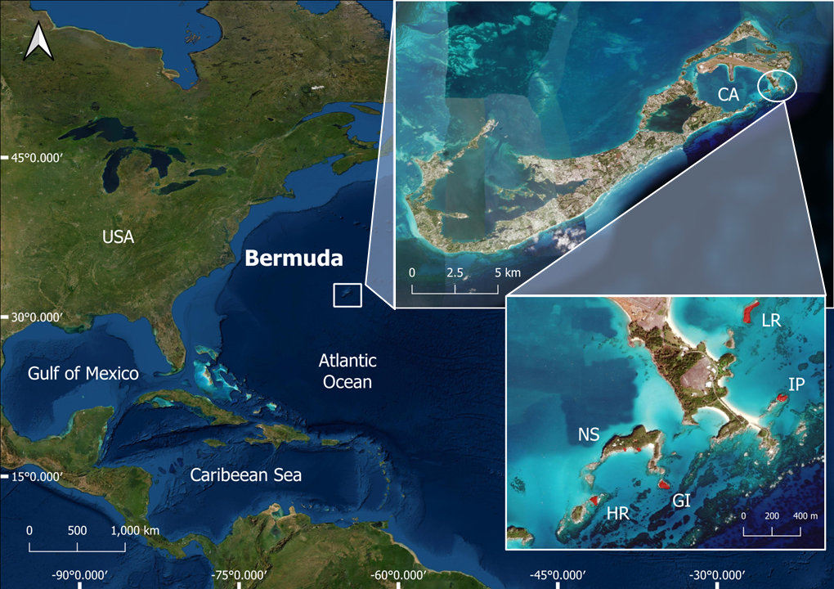
Figure 1

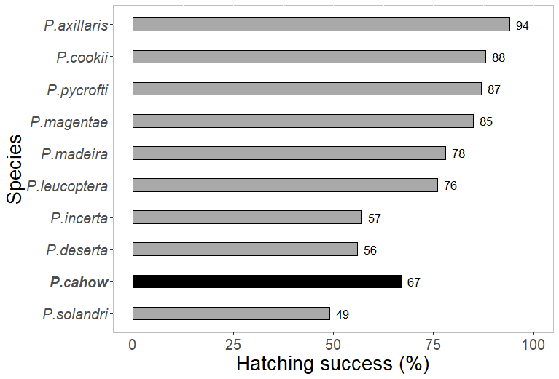
Figure 2

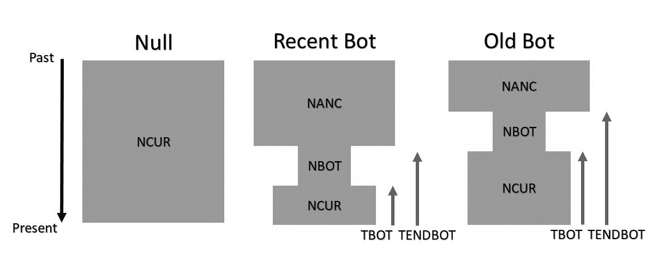
Figure 3

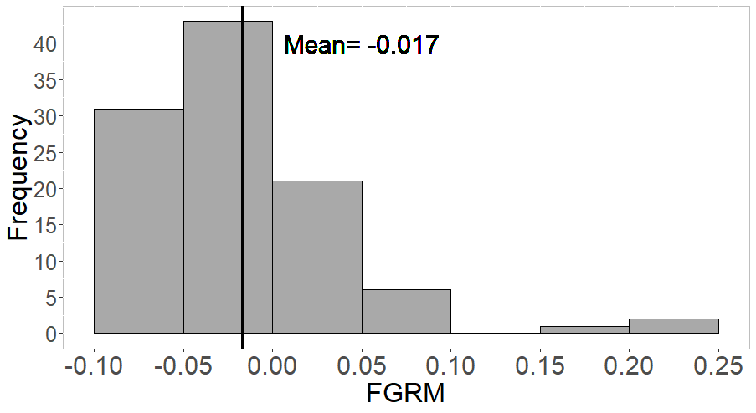
Figure 4

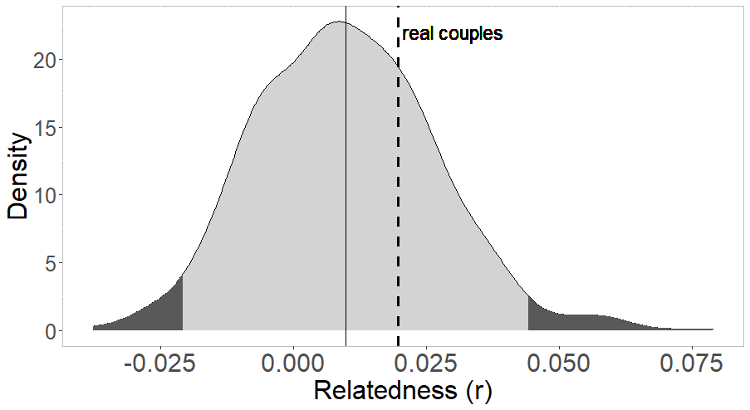
Figure 5


Time (1k years ago)
Ne (1k individuals)
Time (1k generations ago)
Figure 6

